Developer Guide

Ecommerce bag website



Project Mentor Sir Zohaib

Team Members

1 Saad

2 Jahangir

3 Musawar

4 Umer

Contents

Introduction 3

Setting Up the Development Environment 4

Creating the Basic Structure 5

HTML Structure 6

Deployment 7

# **Introduction**

The purpose of this document is to provide an overview of the website. Additionally, the guide serves as a roadmap to help developers understand the detailed steps involved in the development of the solutions.

The website is developed as an e-commerce platform to target end users, and the following tech stack has been used for its development:

* HTML
* CSS
* JavaScript
* Bootstrap
* PHP

# **Setting Up the Development Environment**

VS Code is used for software development, and Bootstrap is used for the online CDN.

<!DOCTYPE html>

<html lang="en">

<head>

    <meta charset="UTF-8">

    <meta http-equiv="X-UA-Compatible" content="IE=edge">

    <meta name="viewport" content="width=device-width, initial-scale=1.0">

    <title>complete responsive hospital website create by win coder</title>

    <!-- *font awesome cdn link*-->

    <link rel="stylesheet" href="https://cdnjs.cloudflare.com/ajax/libs/font-awesome/5.15.4/css/all.min.css">

    <!-- *custom css file link*-->

    <link rel="stylesheet" href="css/style.css">

</head>

# **Creating the Basic Structure**

Separate folders are used for styling and functionality, which include CSS files, JS files, and background images.

The basic files used for the development of the structure include Index.html, product.html, femalebags.html, malebags.html, backpack.html, about.html, contact.html, login.html, and signup.html.

# **HTML Structure**

Bootstrap default classes are used for the navigation bar and footer, with a hover effect applied through custom CSS. The bootstrap classes are overridden to create a mobile-friendly and responsive design.

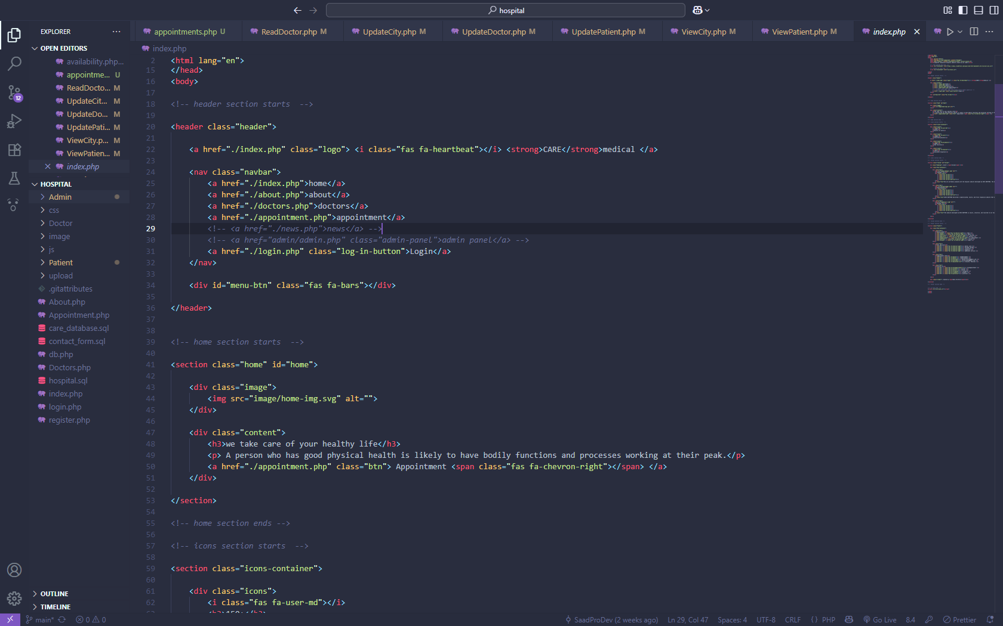

# **Deployment**

Create a GitHub repository and initialize it with the project folder. Write and test the code, then use GitHub Pages for static hosting to deploy the project.

**HTML CODE – Home Page**

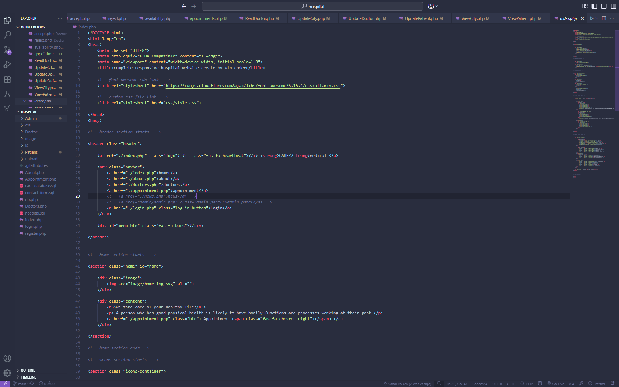

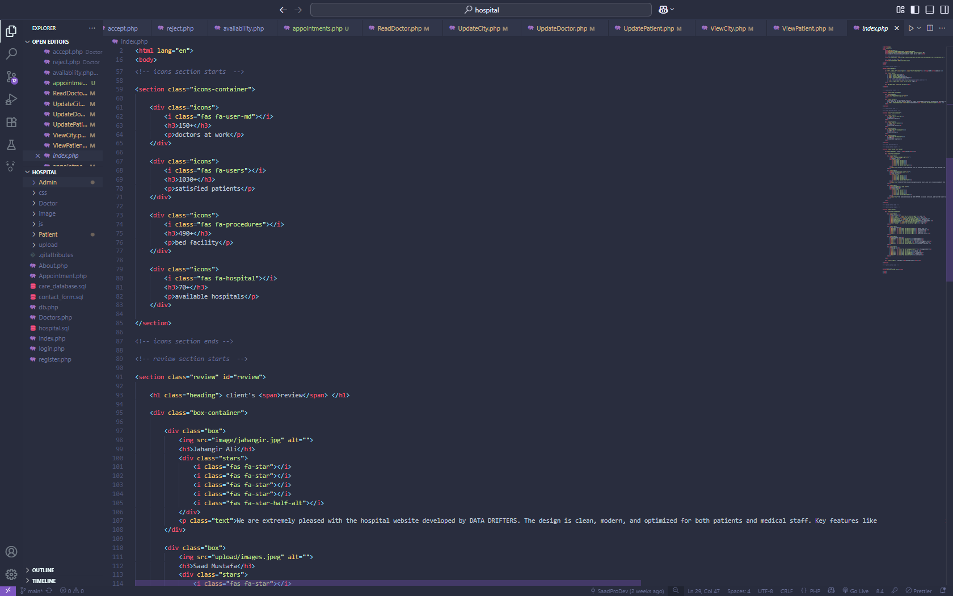

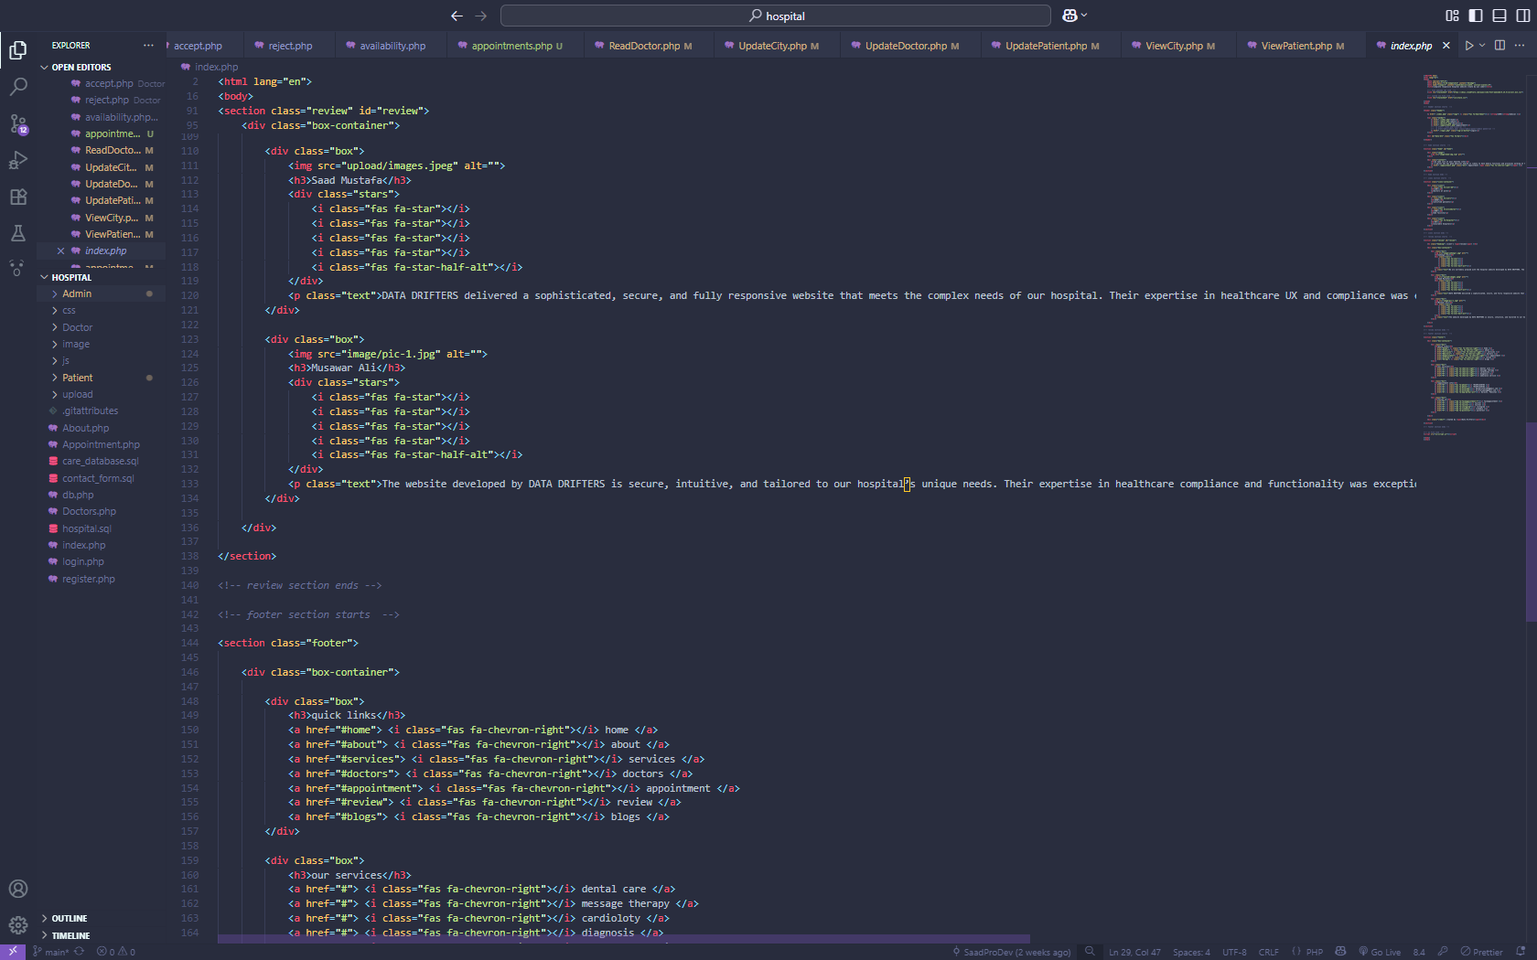

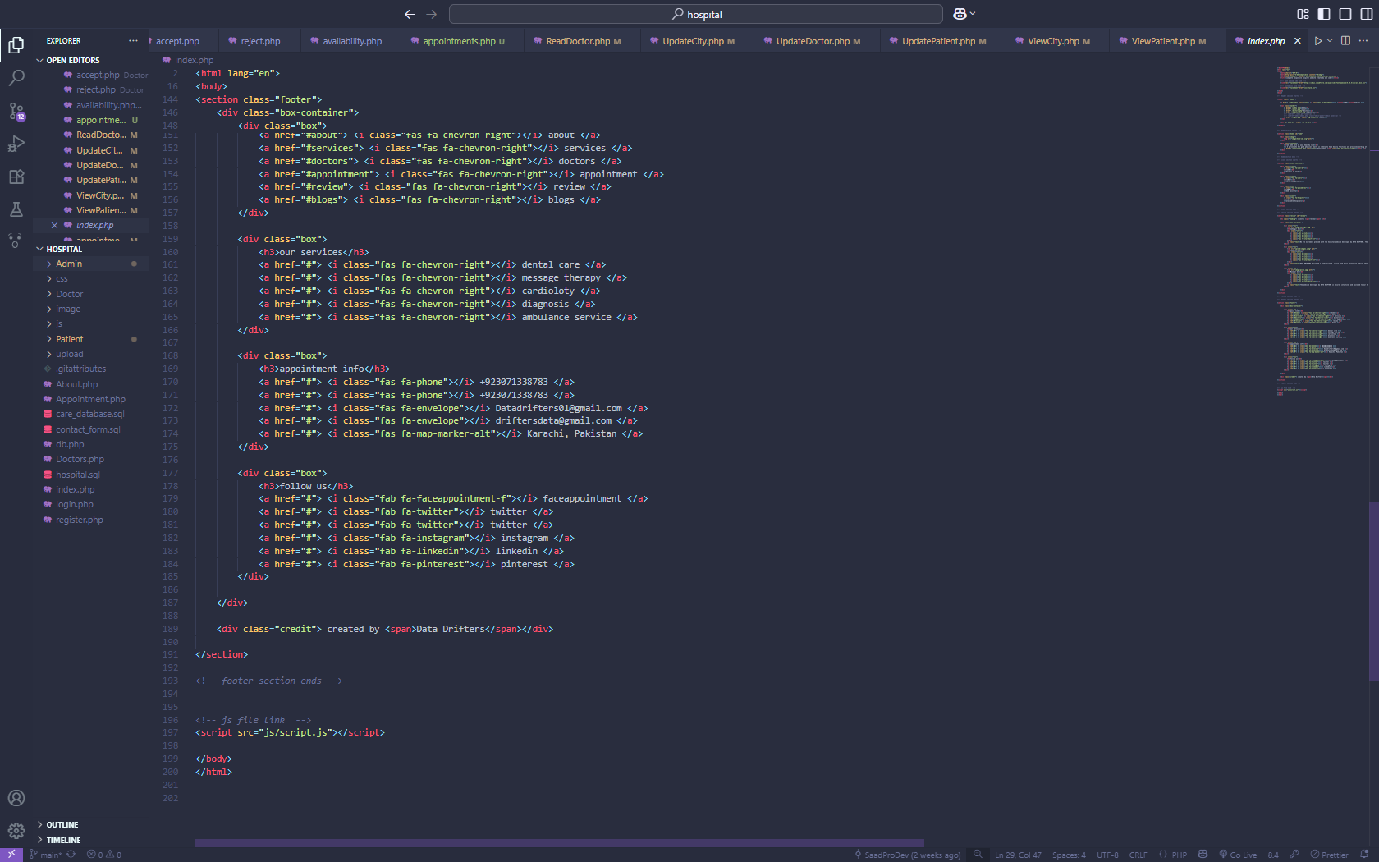

**APPOINTMENT PAGE**

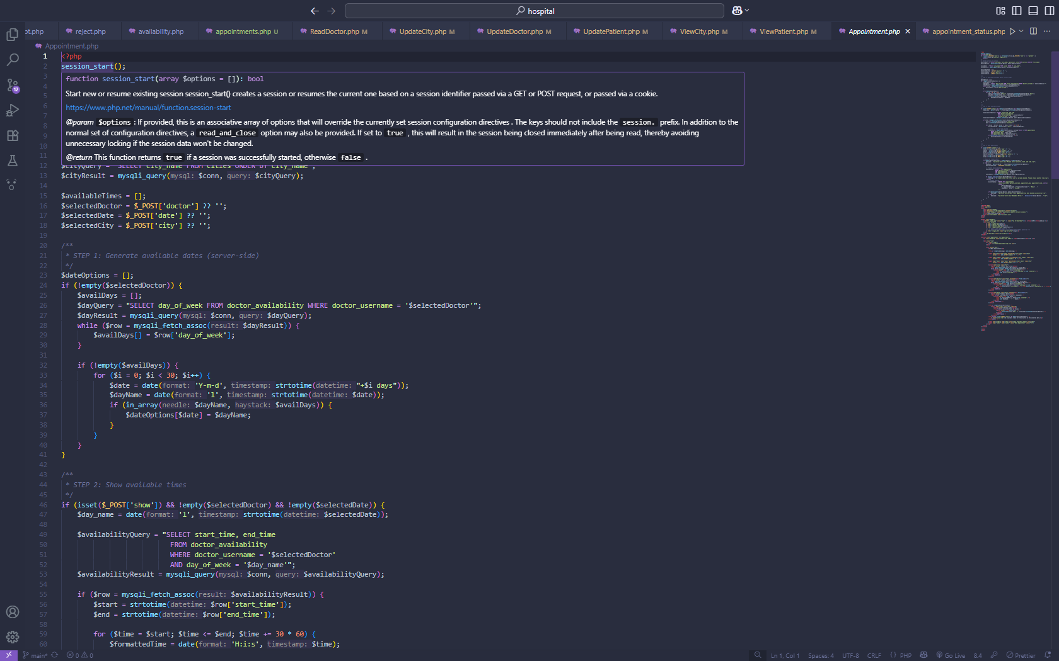

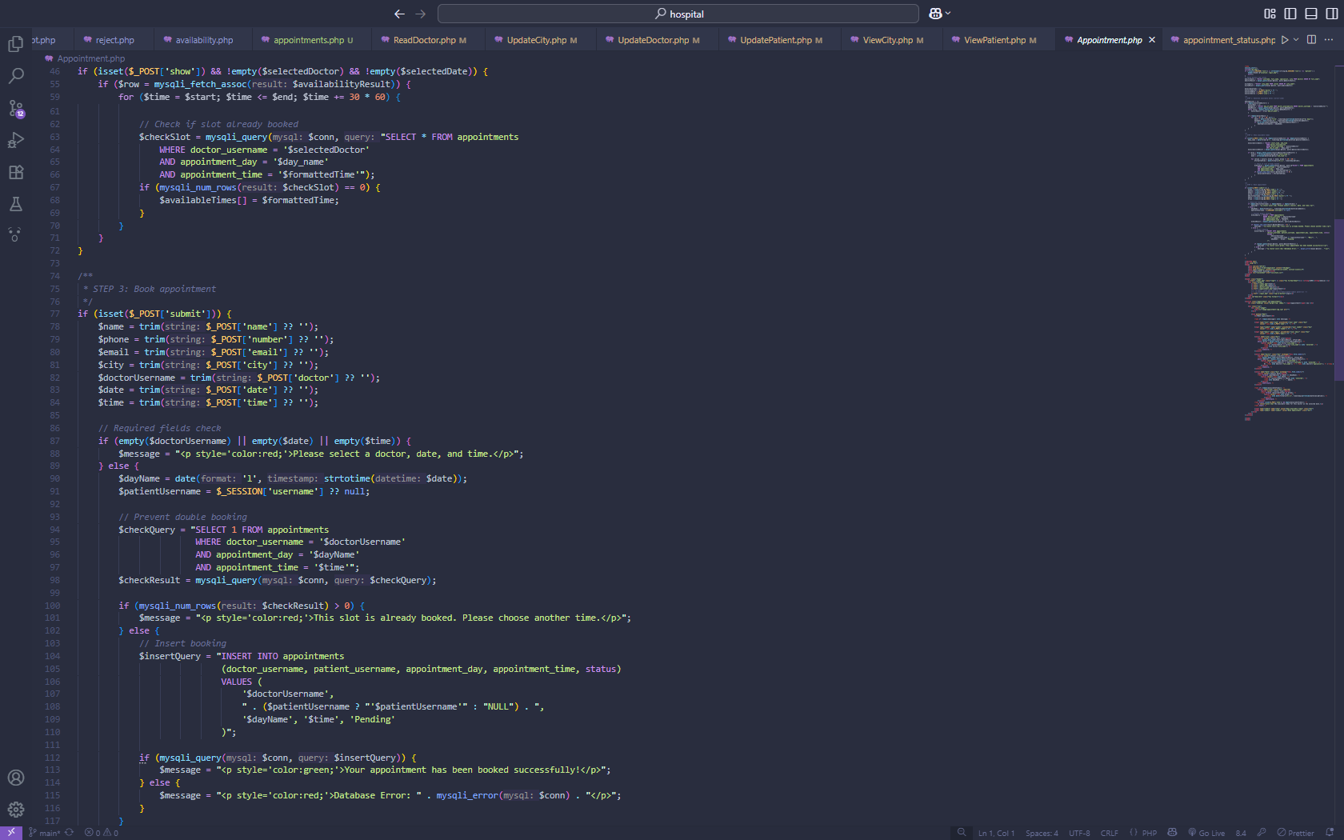

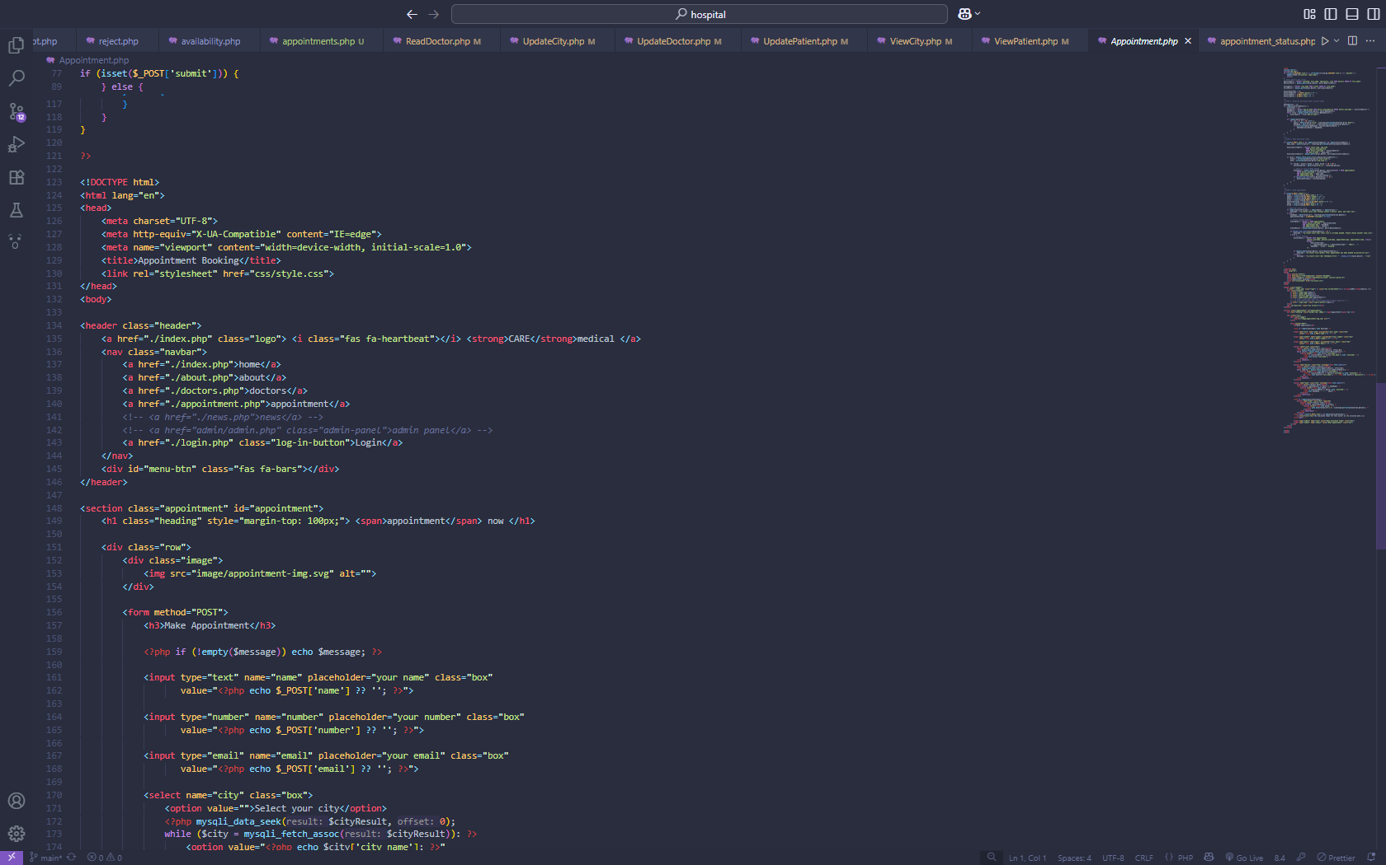

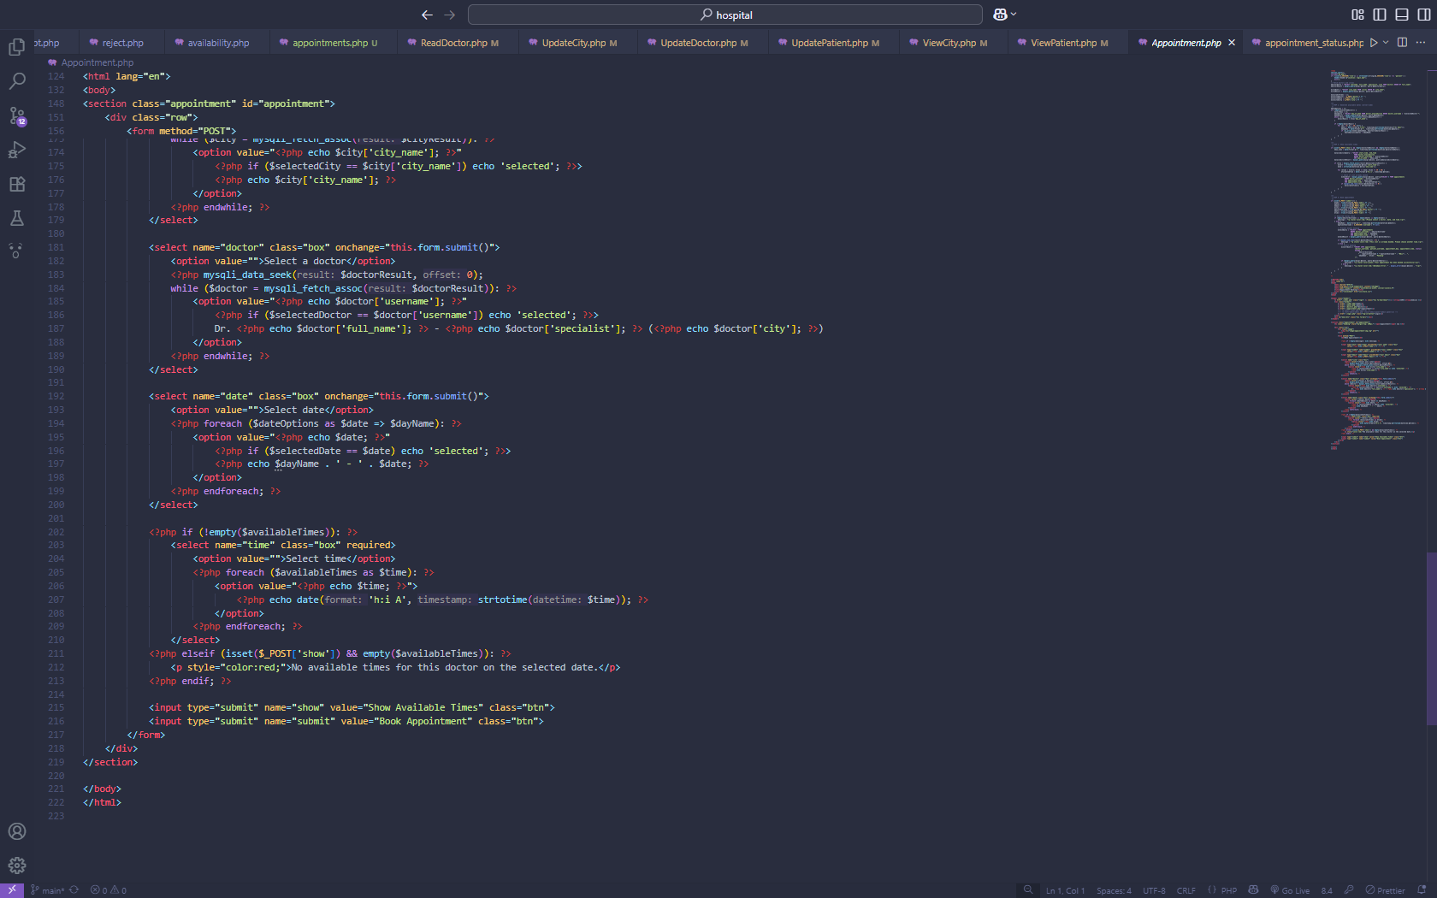

**Doctors PAGE**

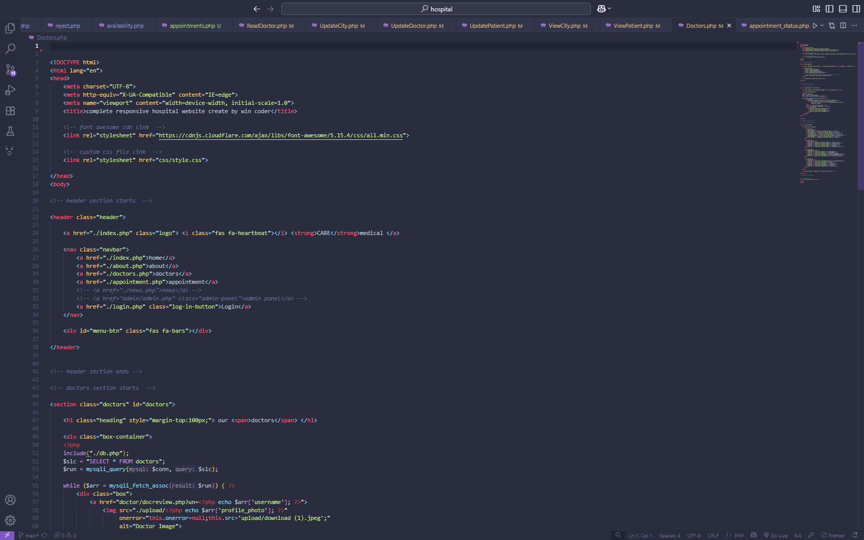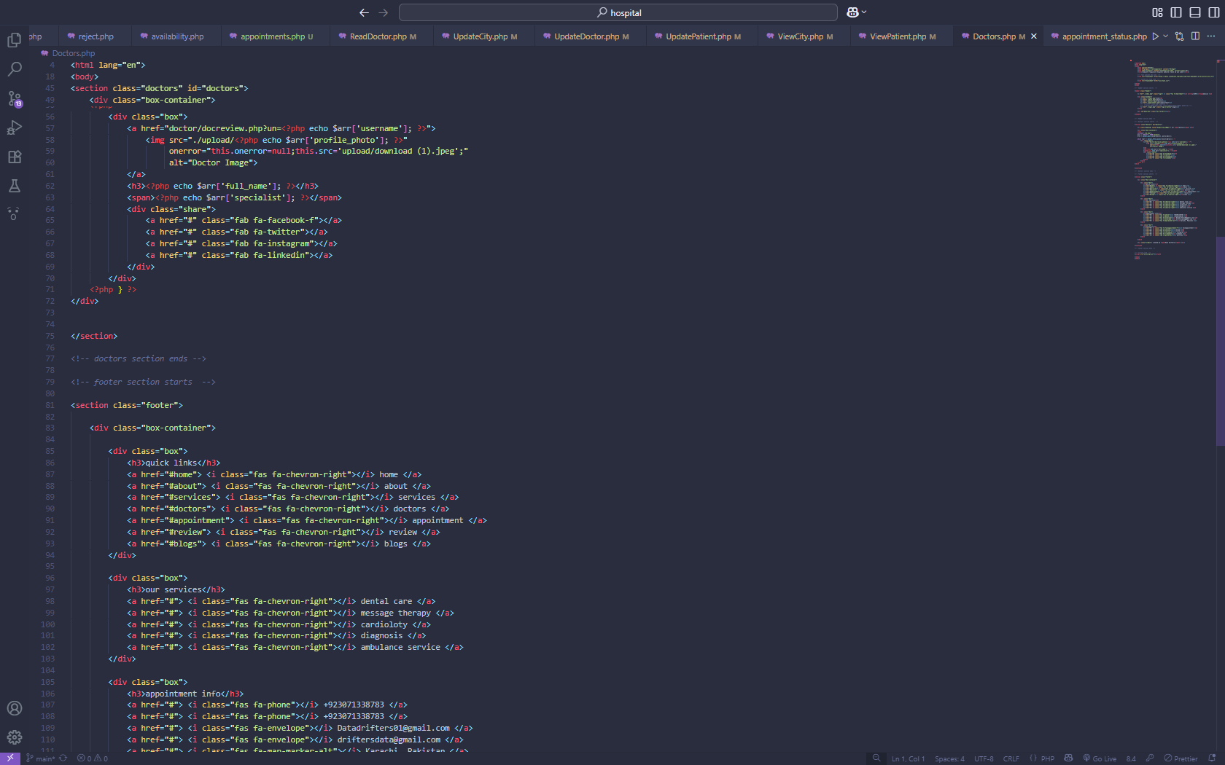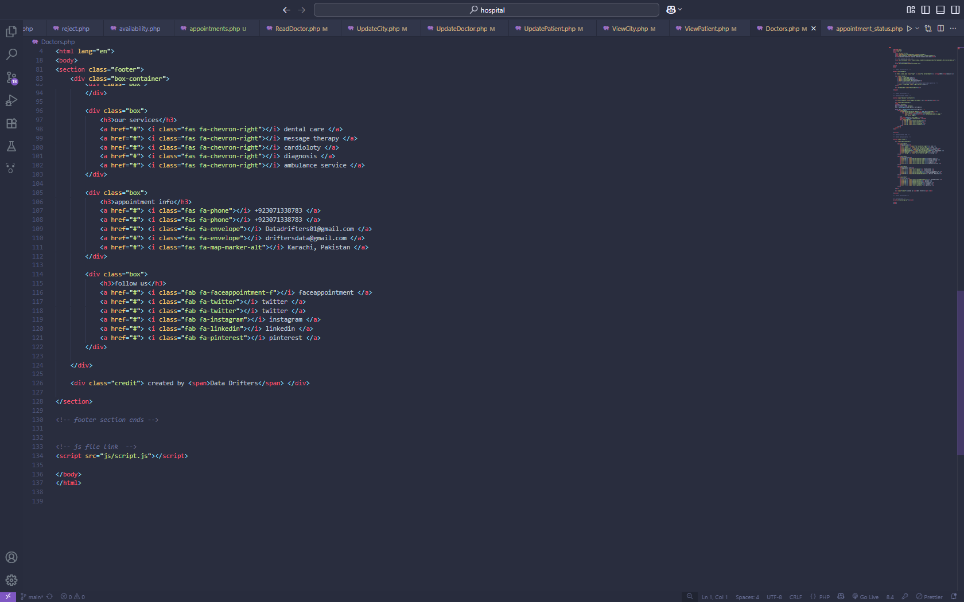

DATABASE CONNECTION PAGE

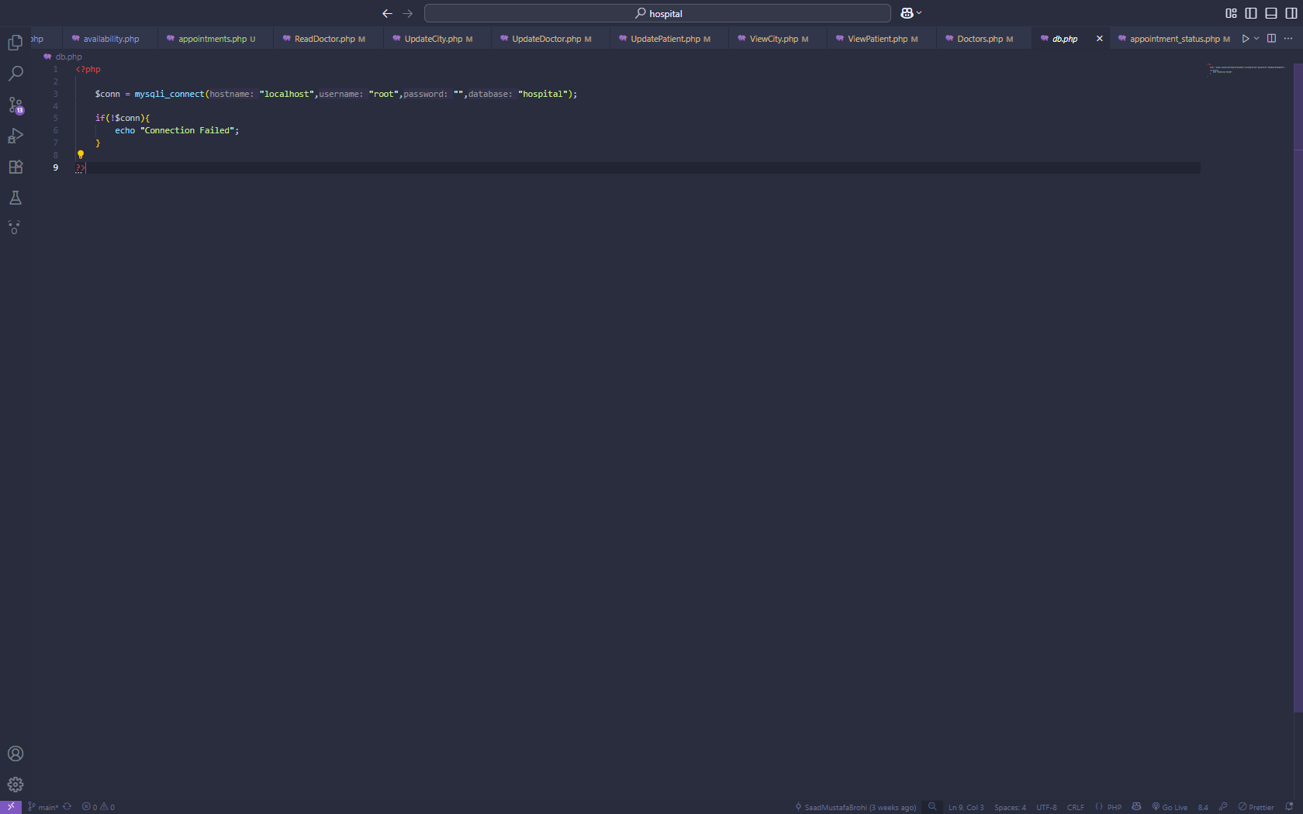

LOGIN Page

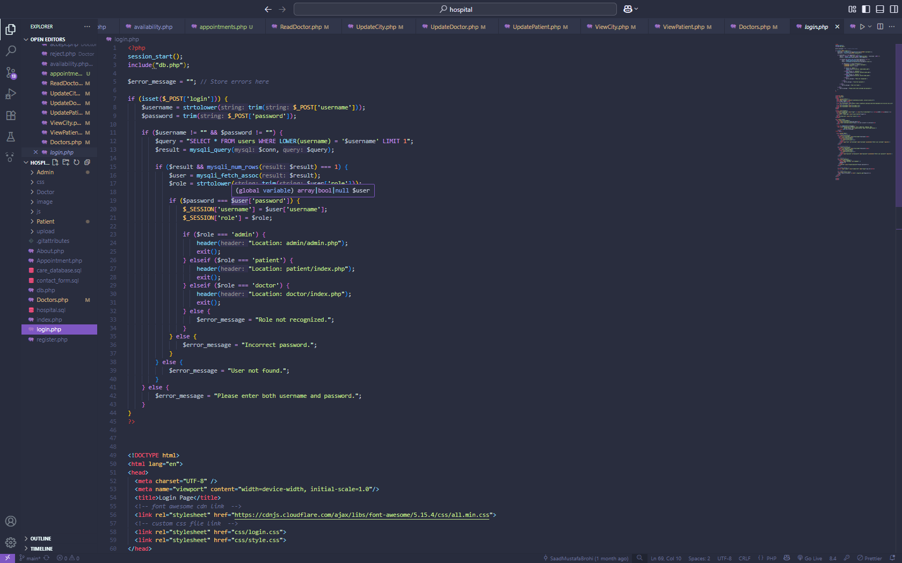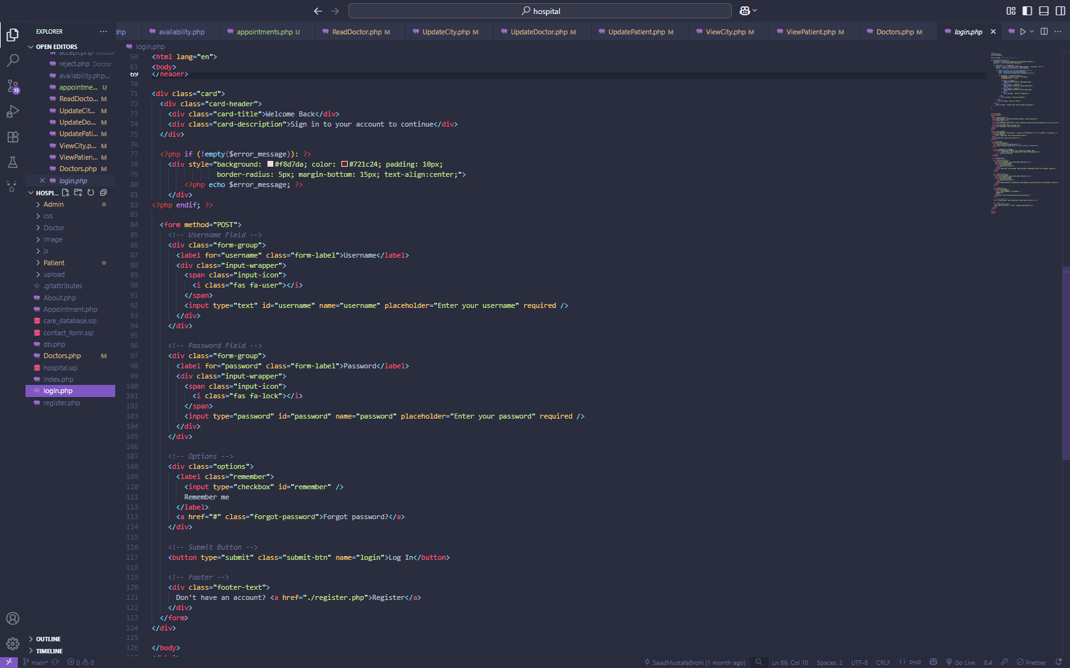

**REGISTER PAGE** 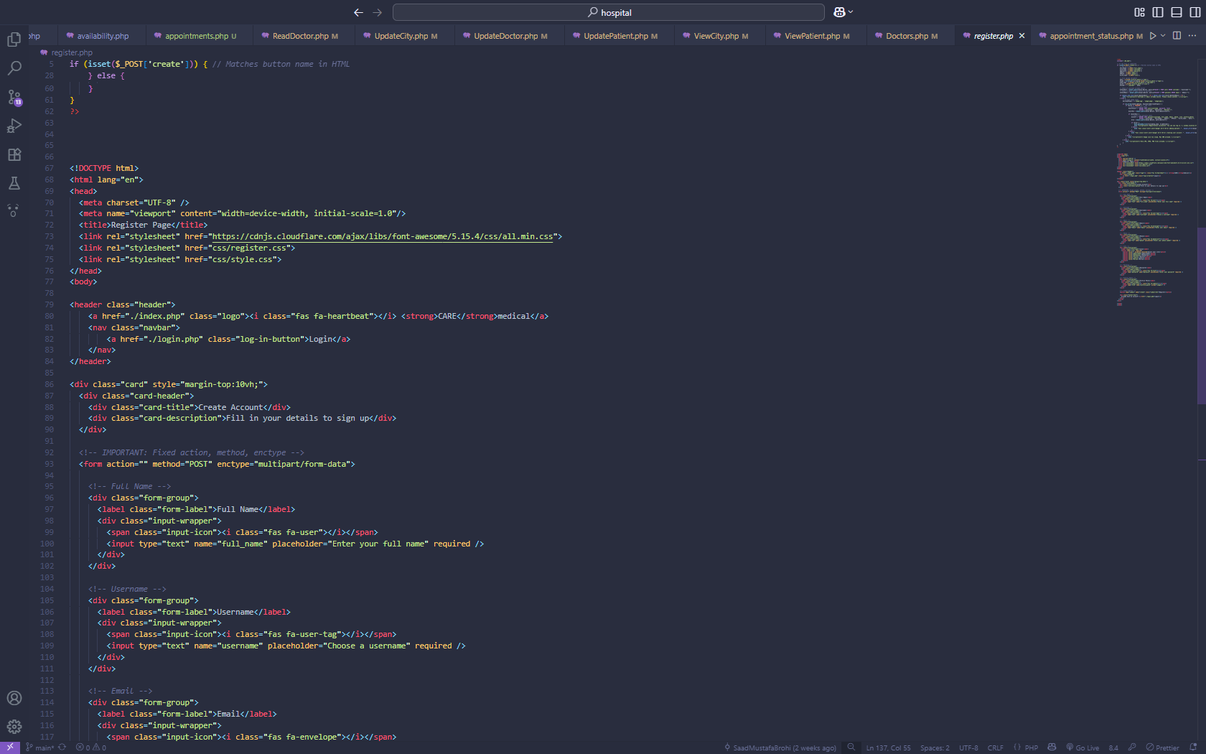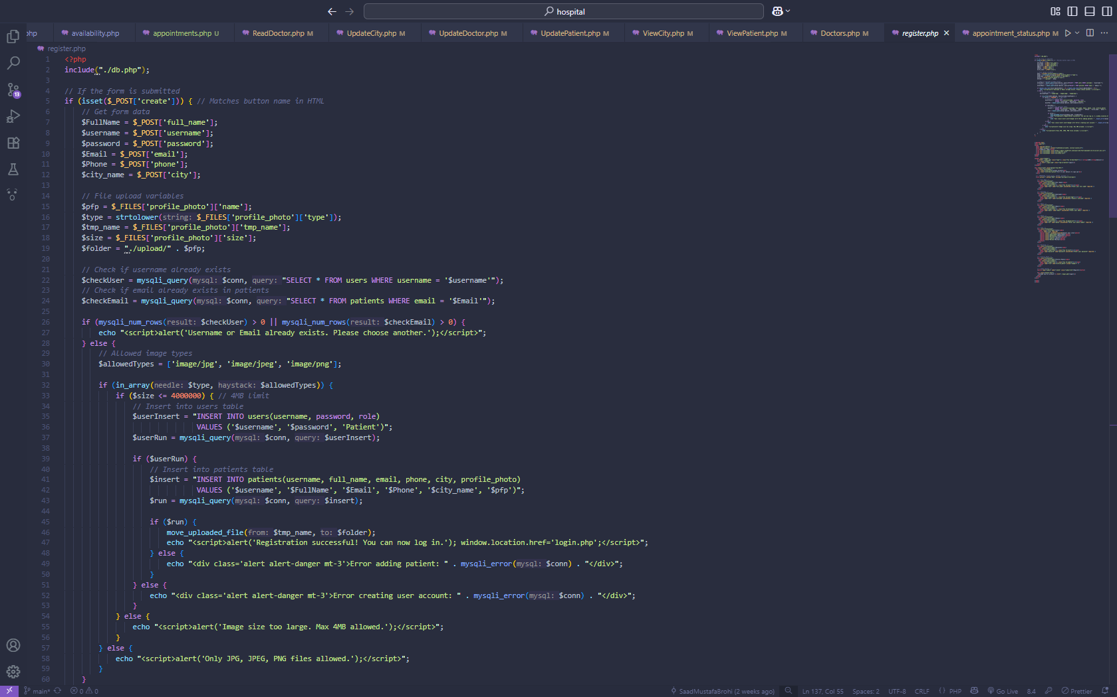

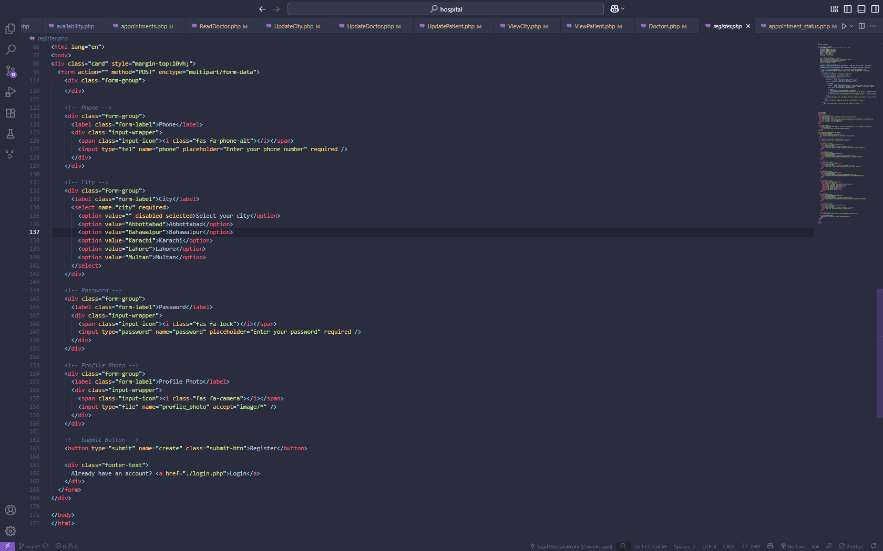

**Doctor - Home PAGE**

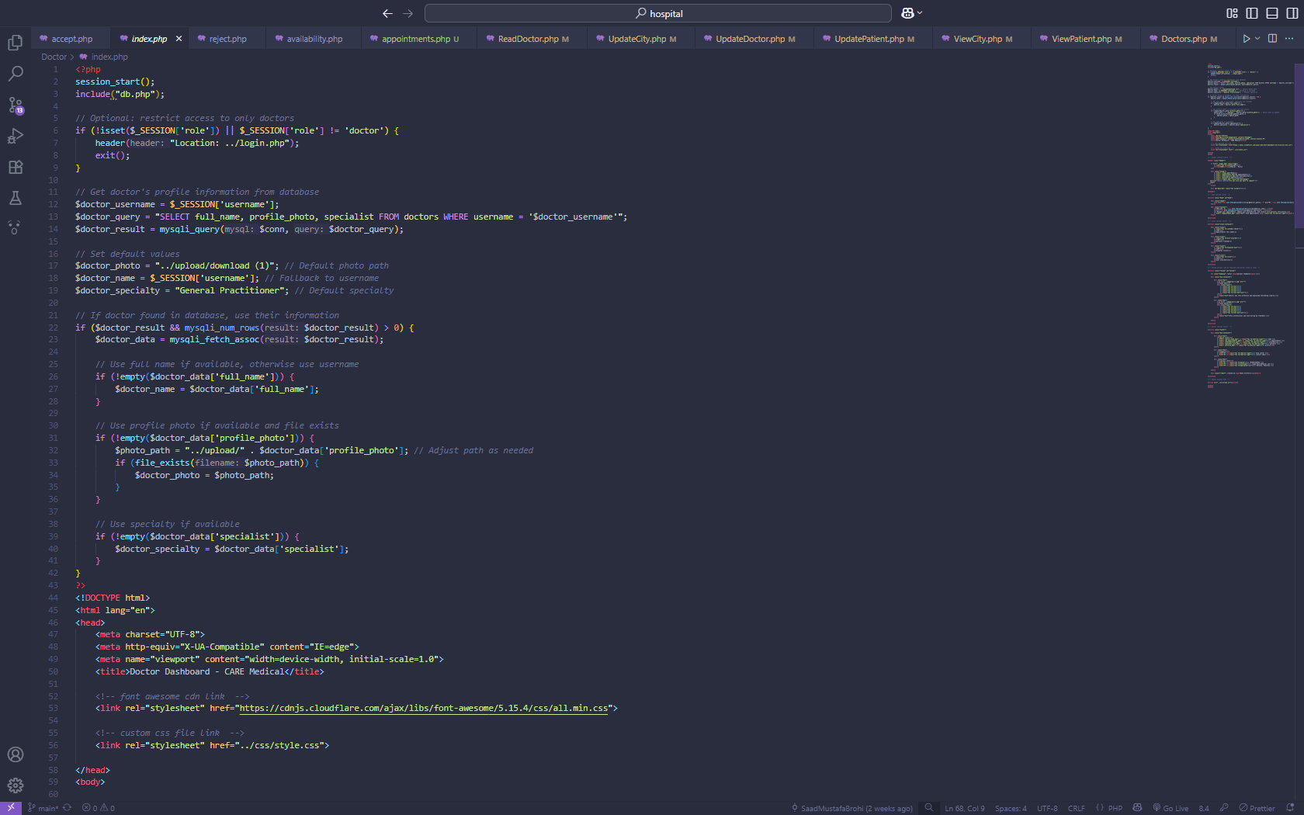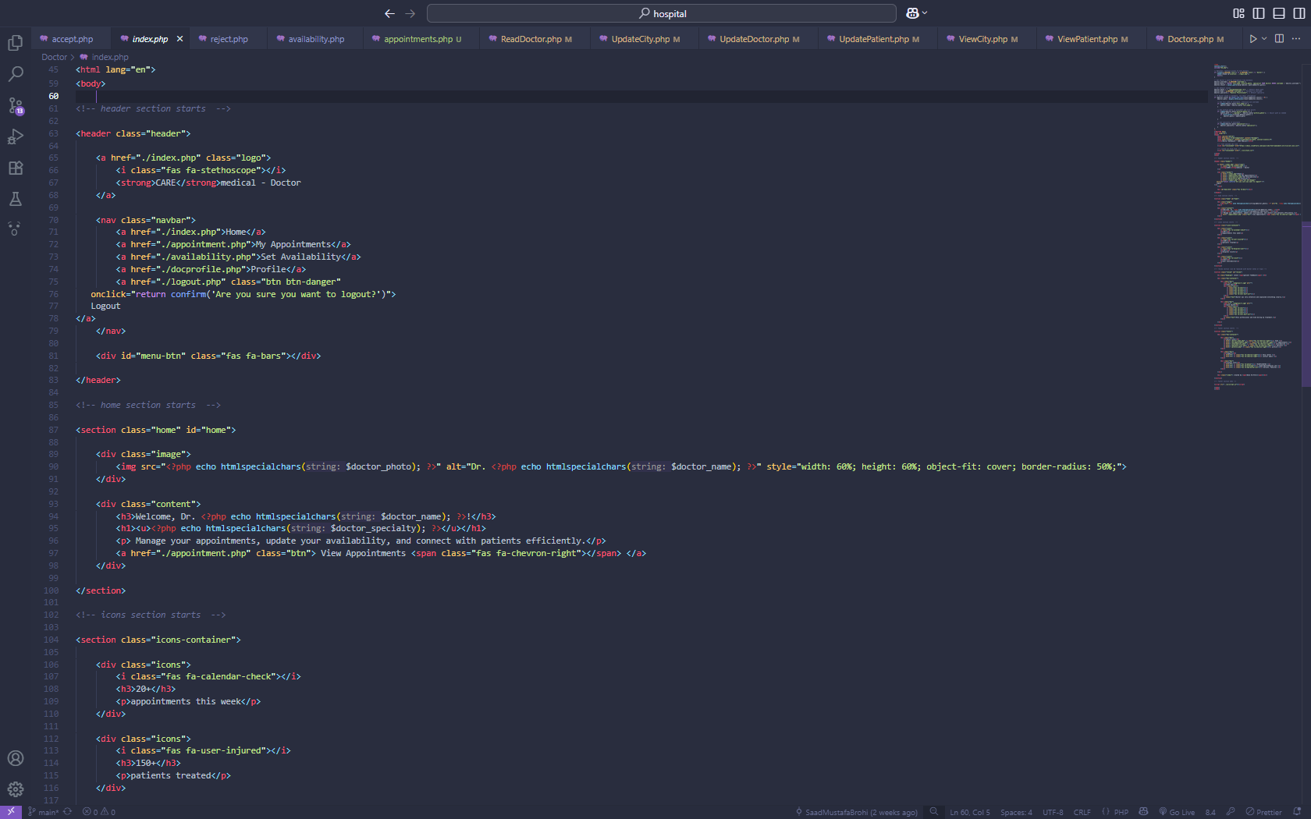

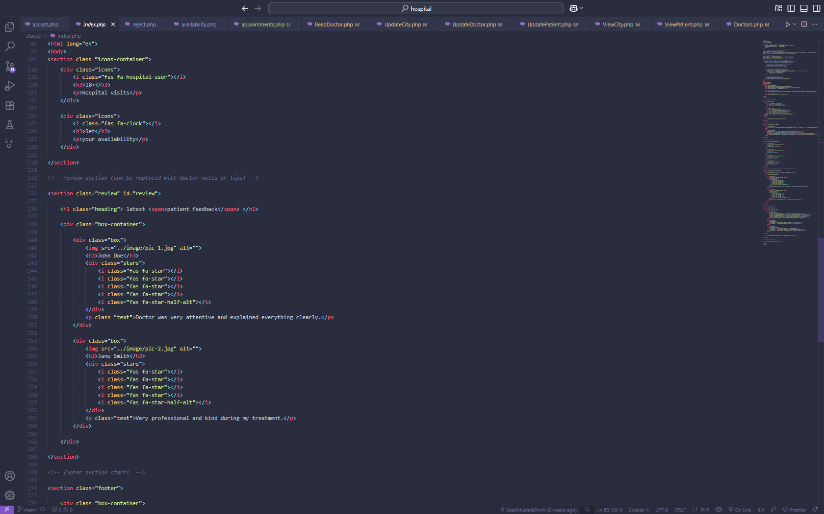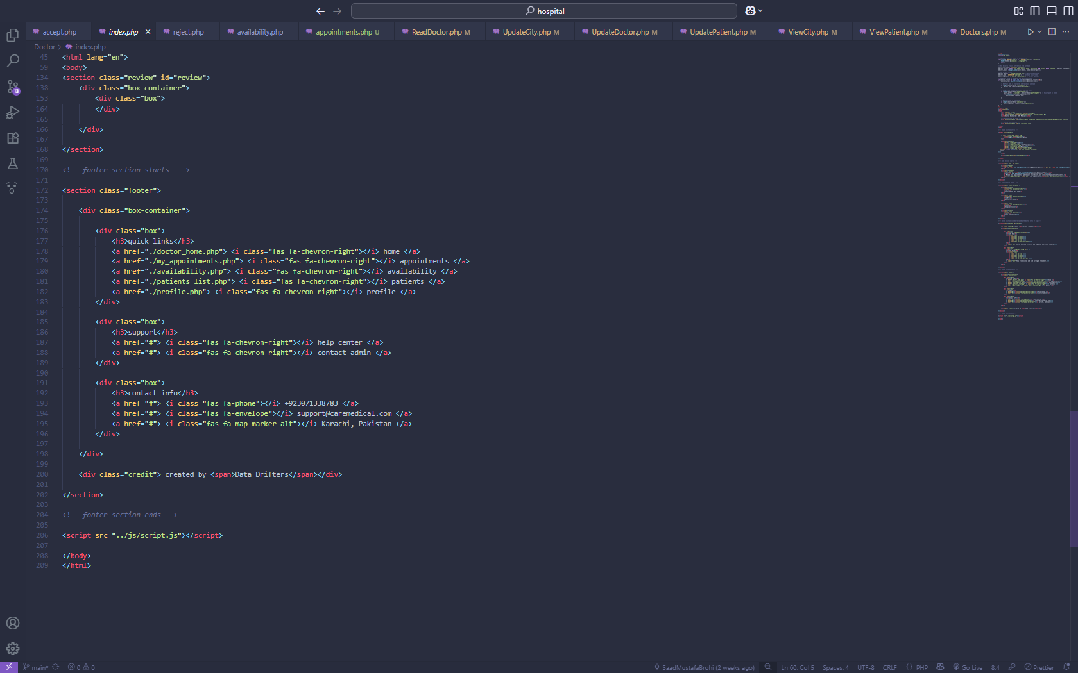

**Doctor -Appointment PAGE**

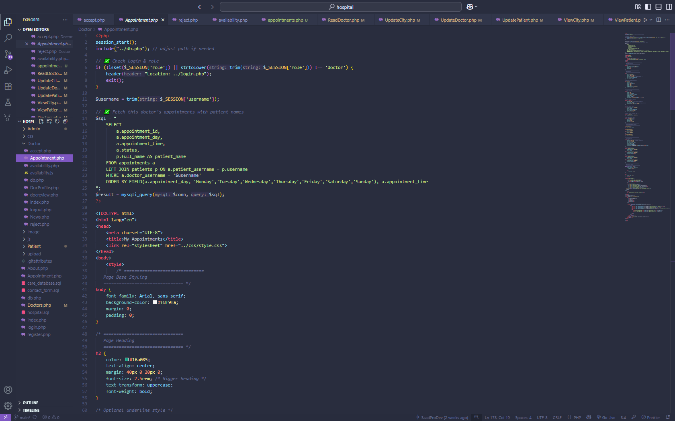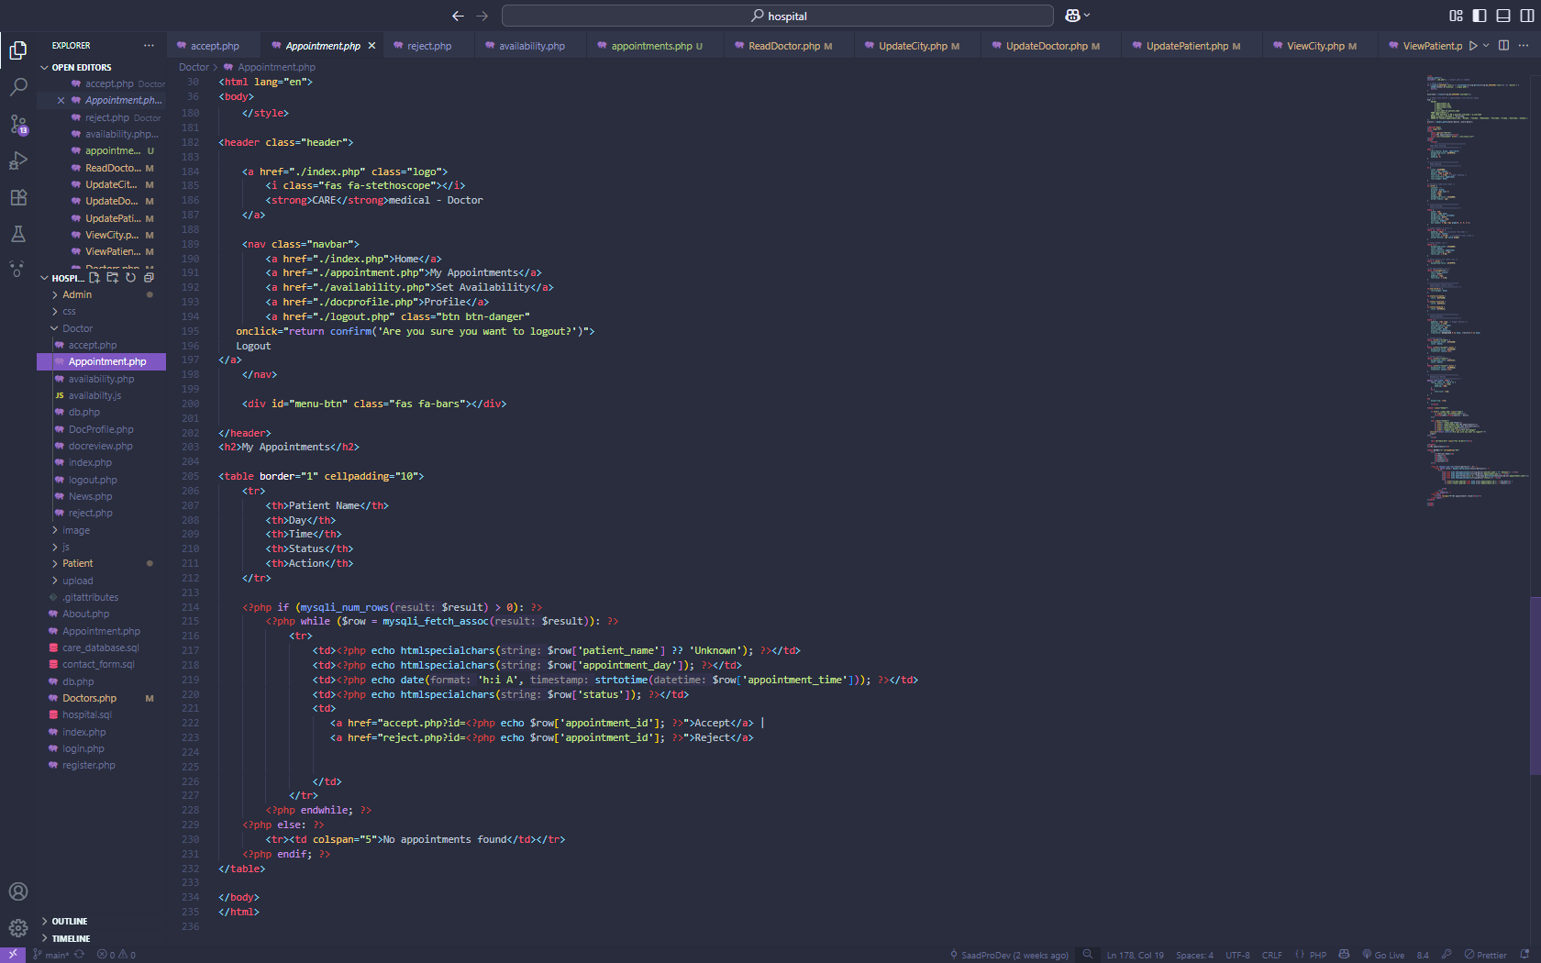

**DOCTOR– SET AVAILABILITY PAGE**

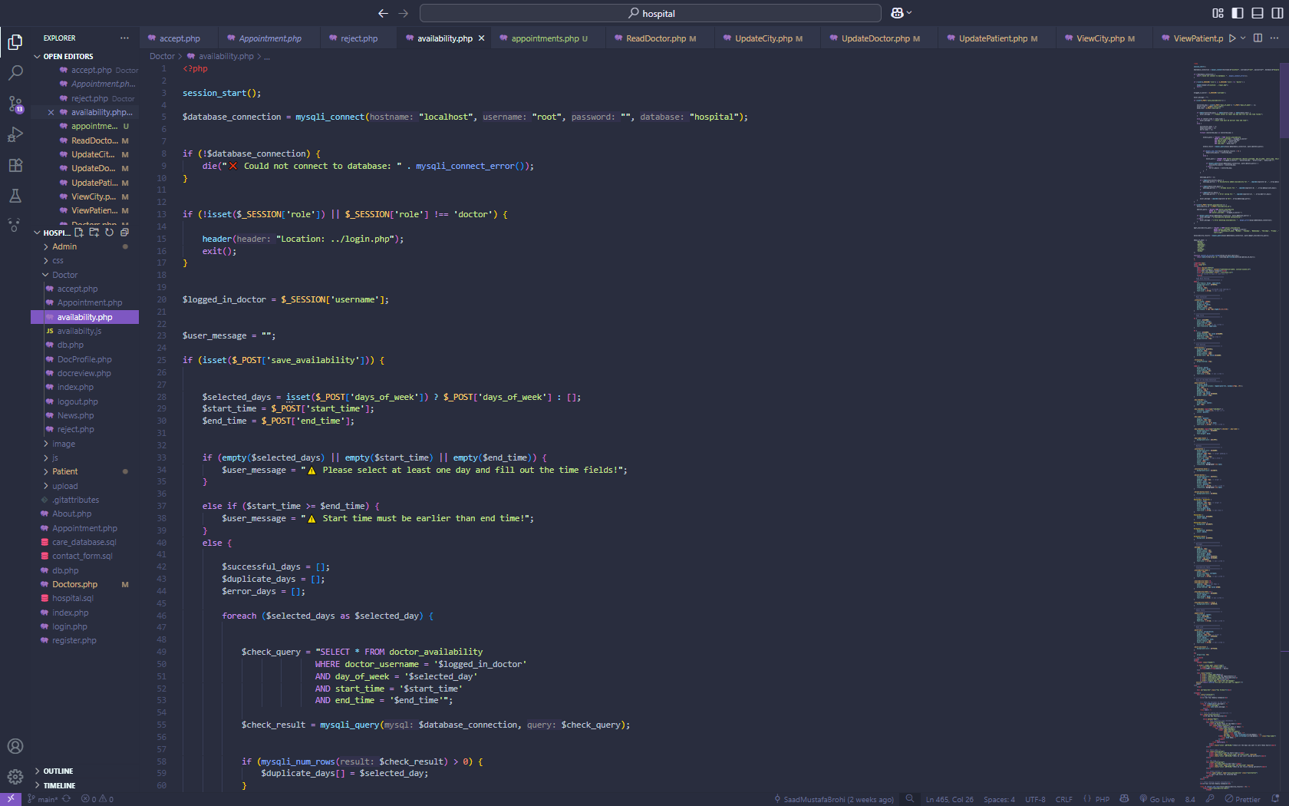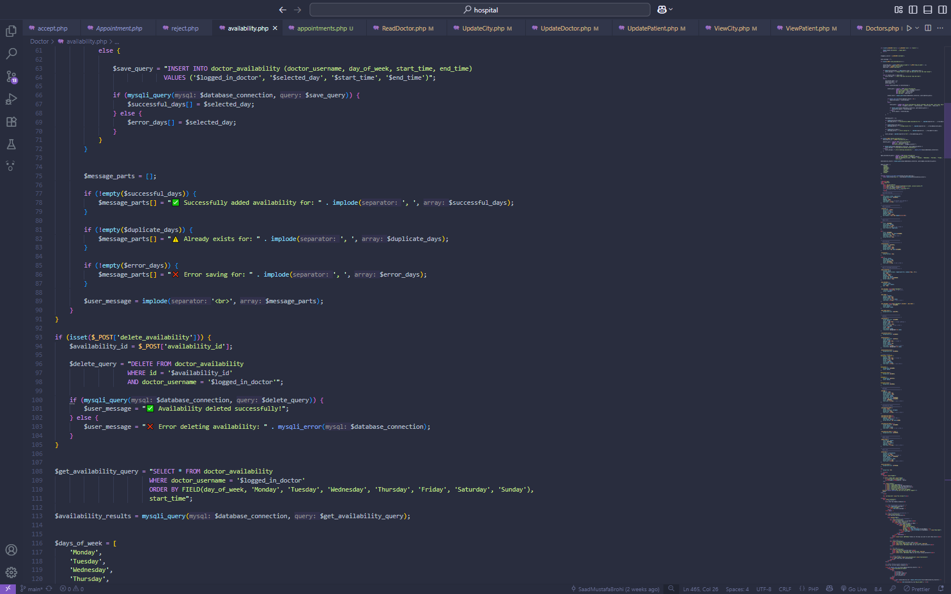

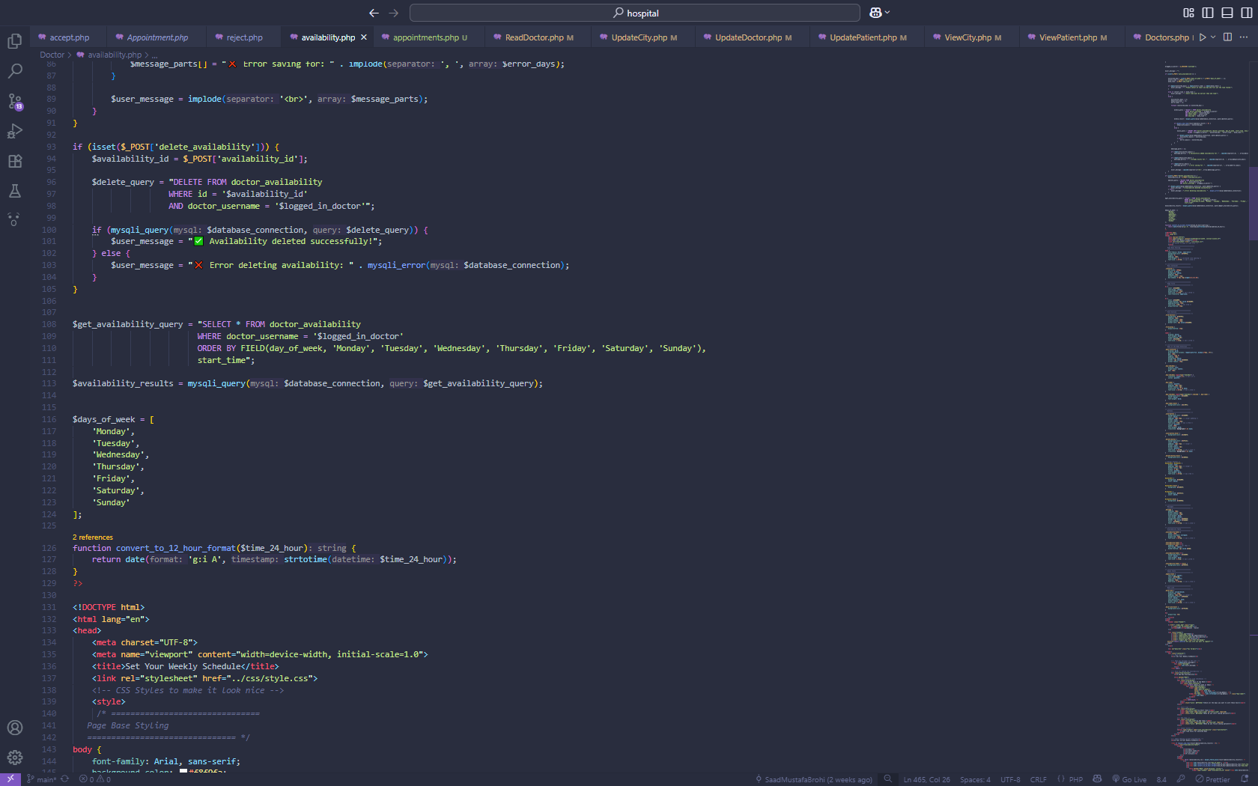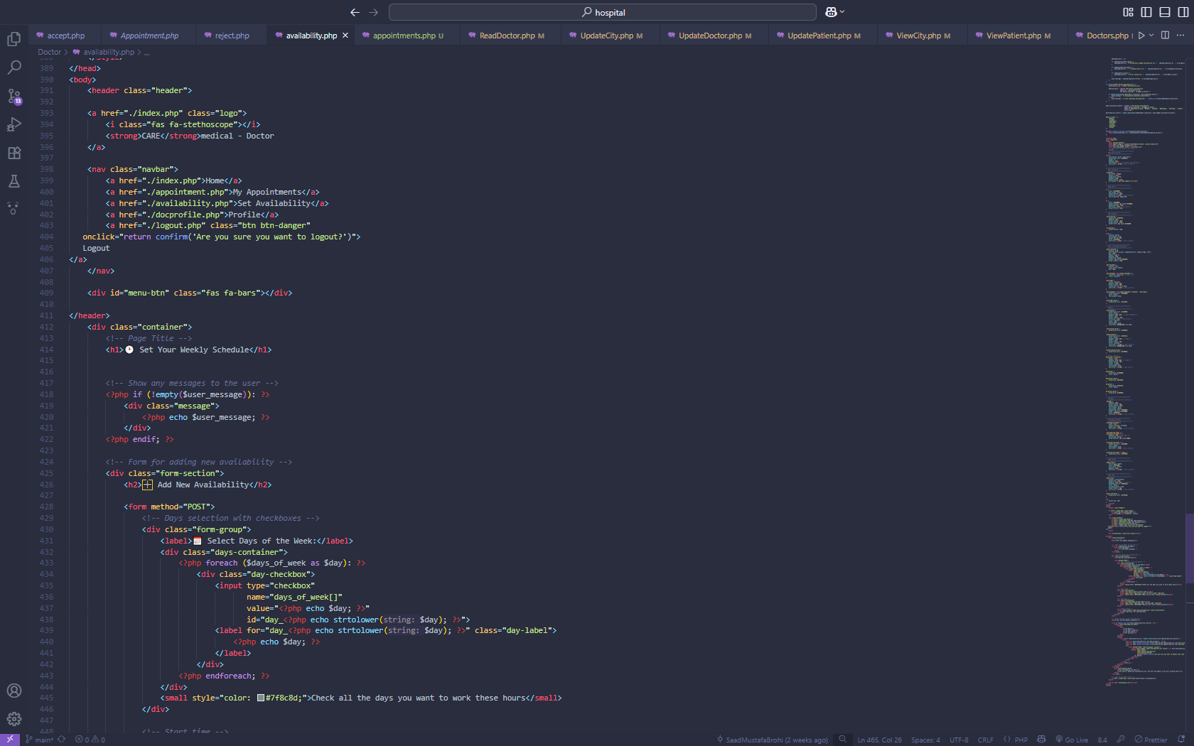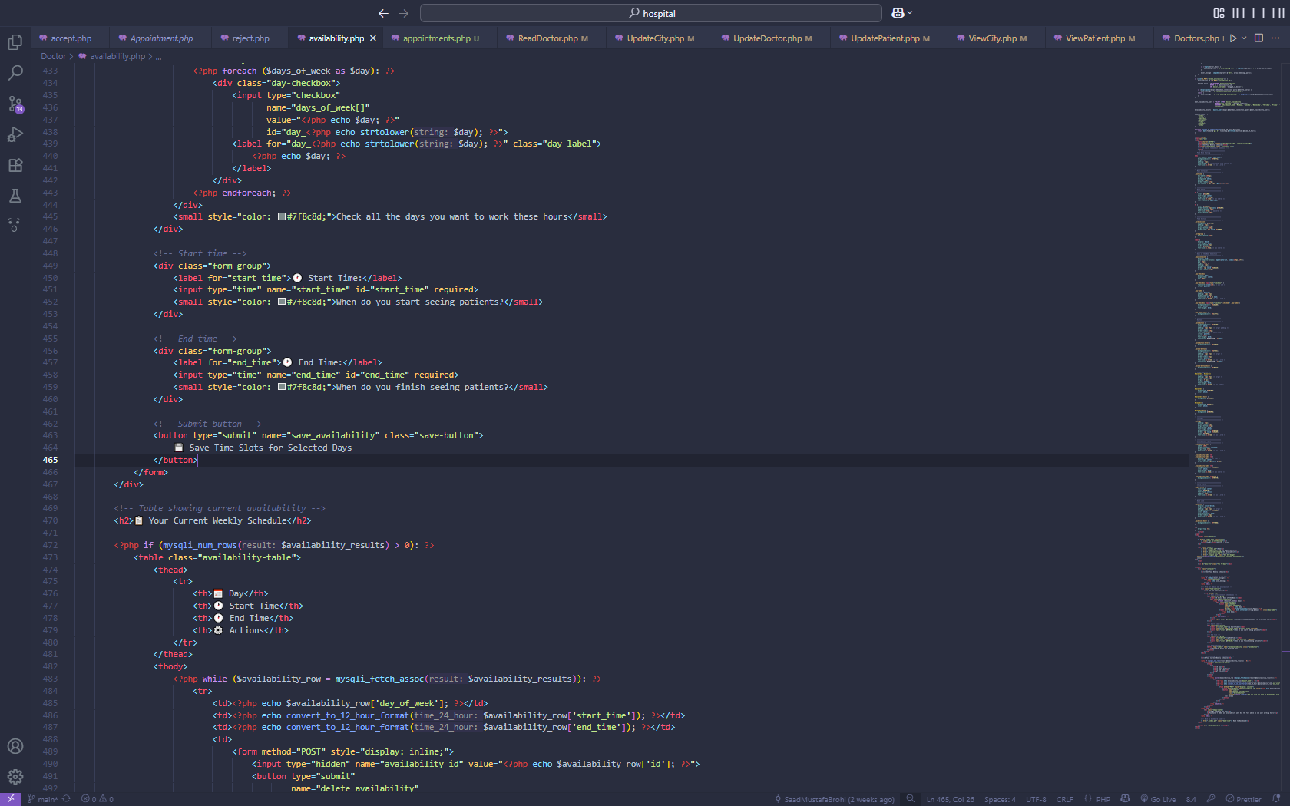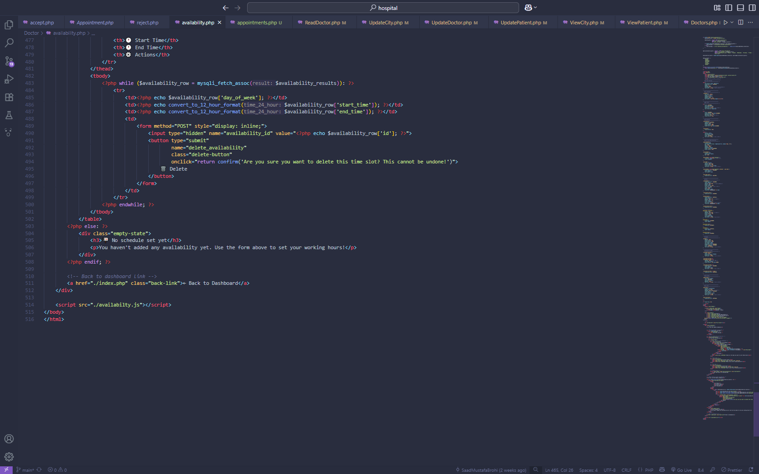

**Doctor- ACCEPT Page AND REJECT PAGE**

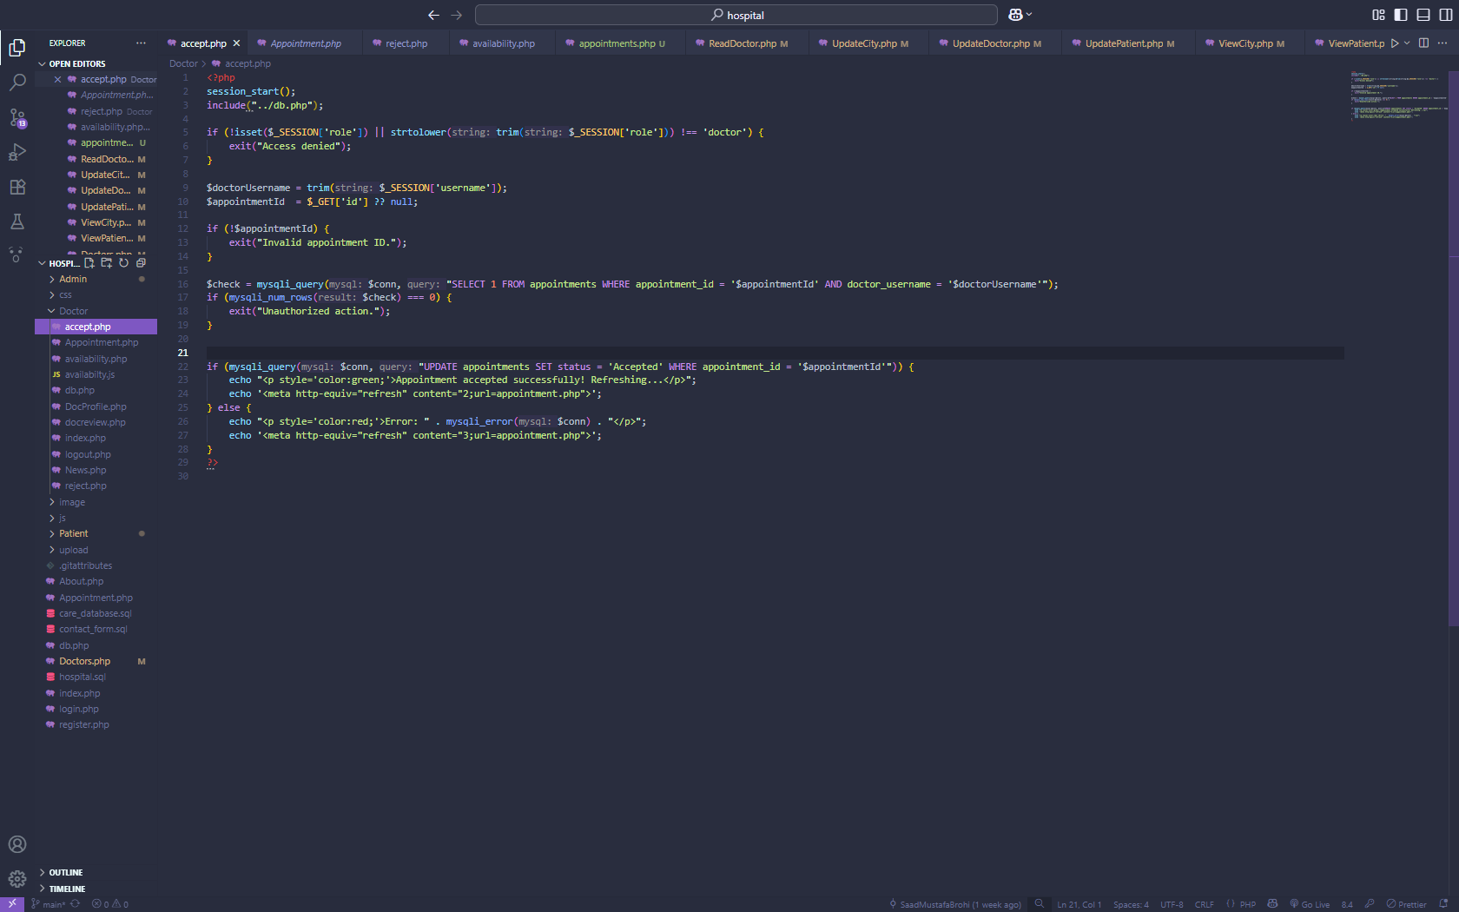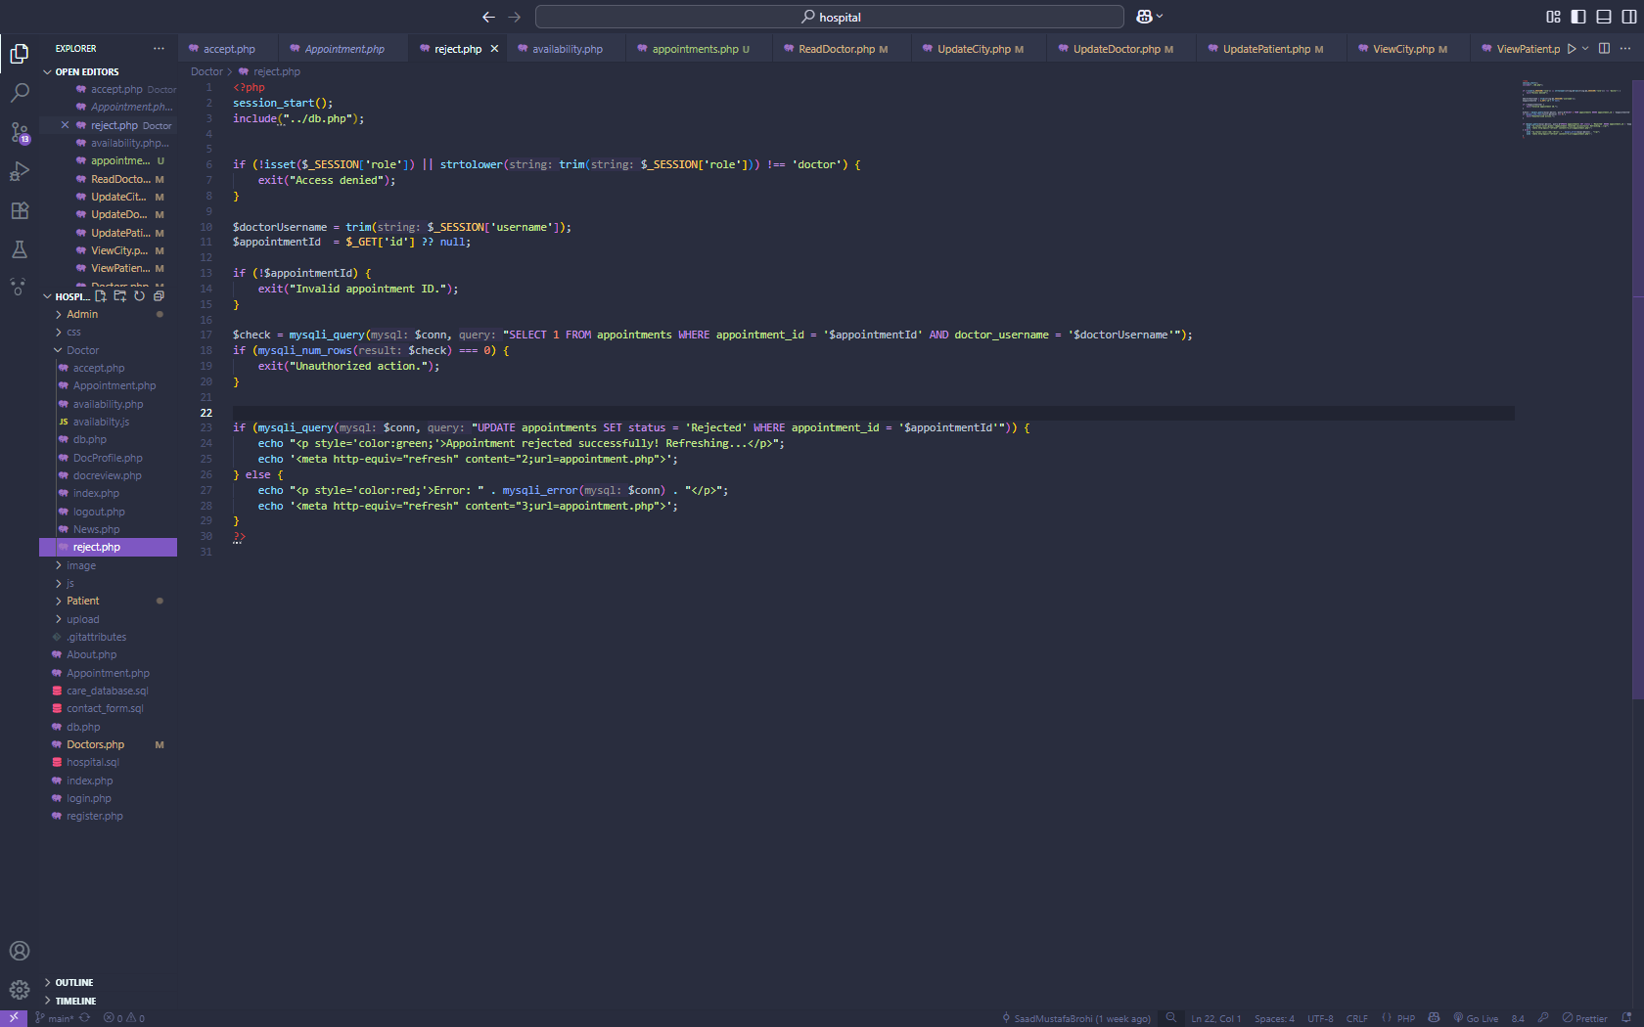

**Patient – appointment page**

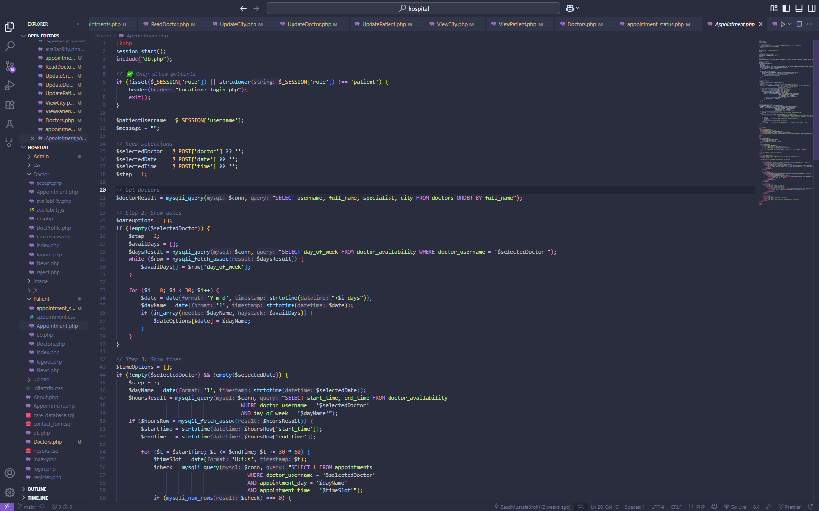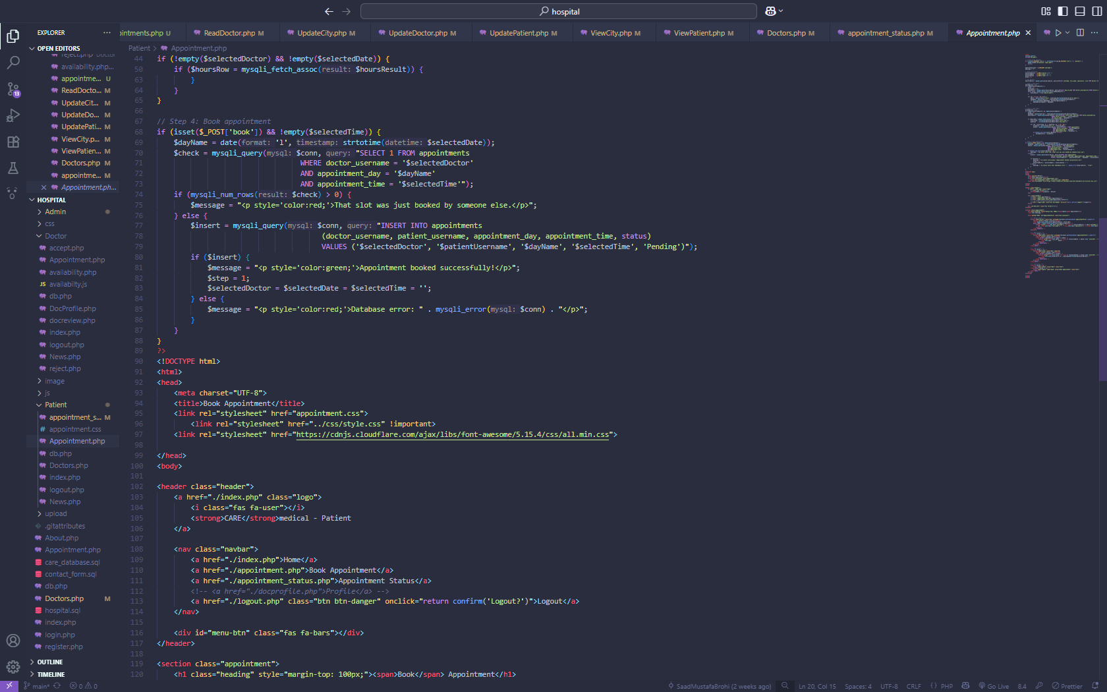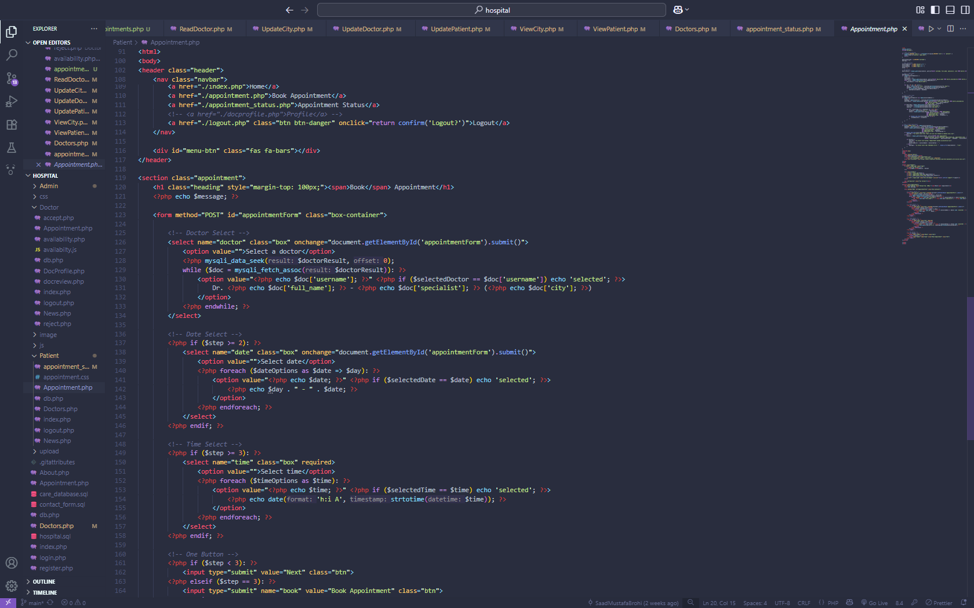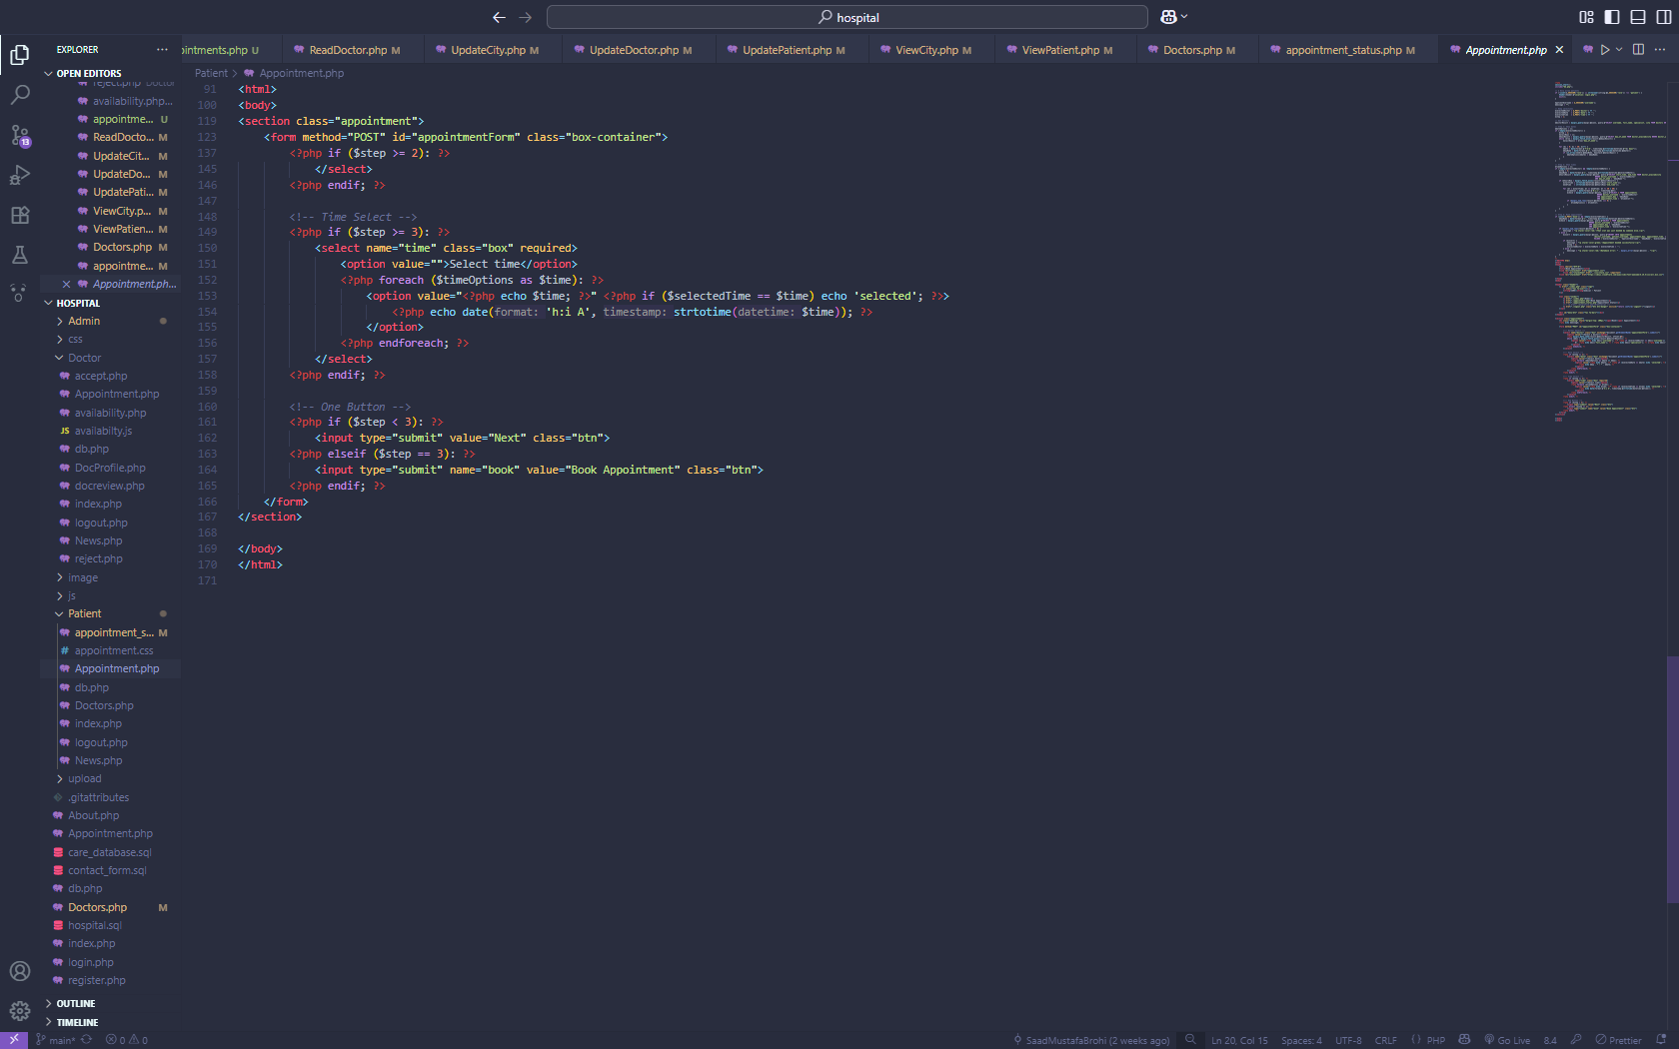

**Patient – Appointment Status Page**

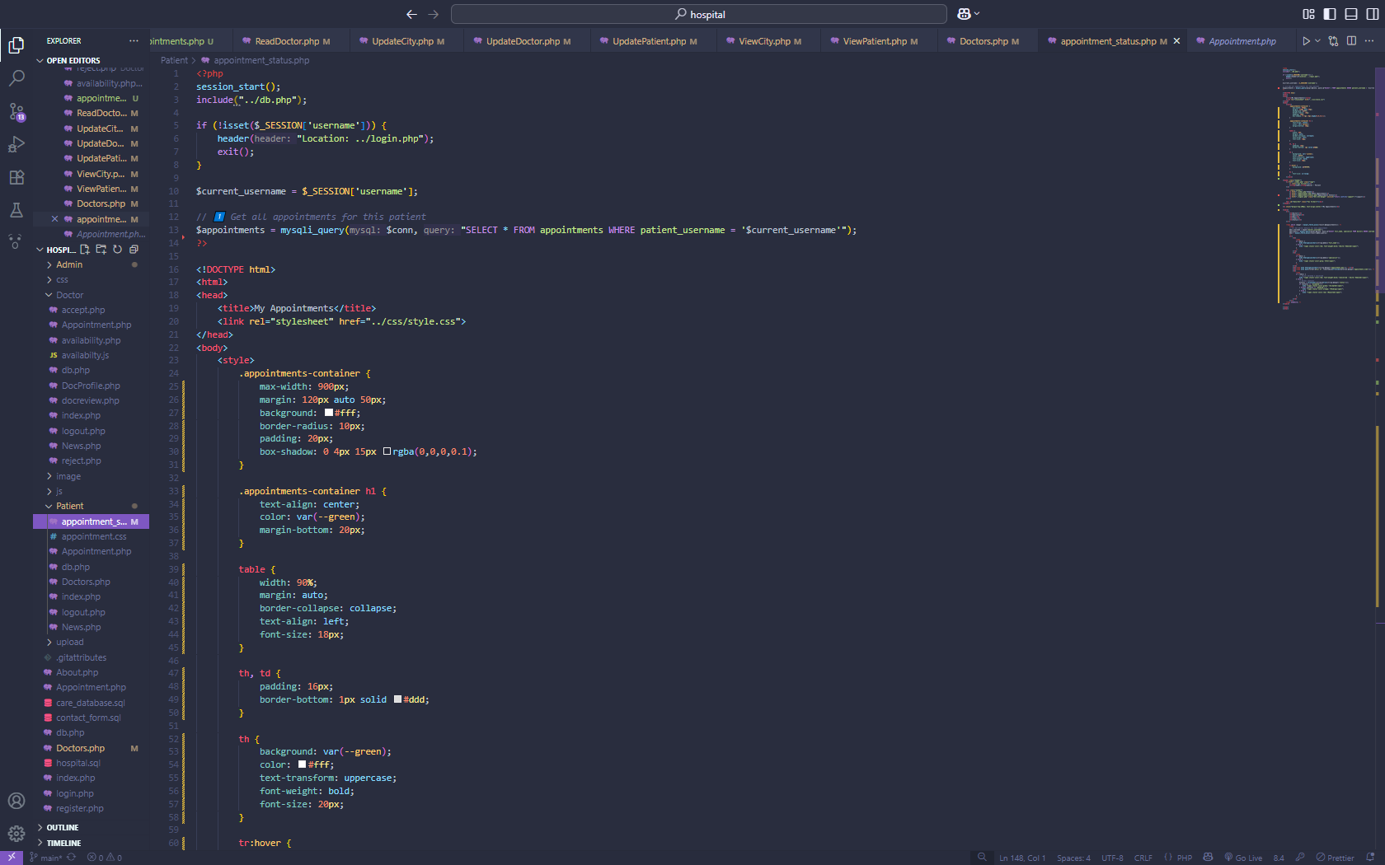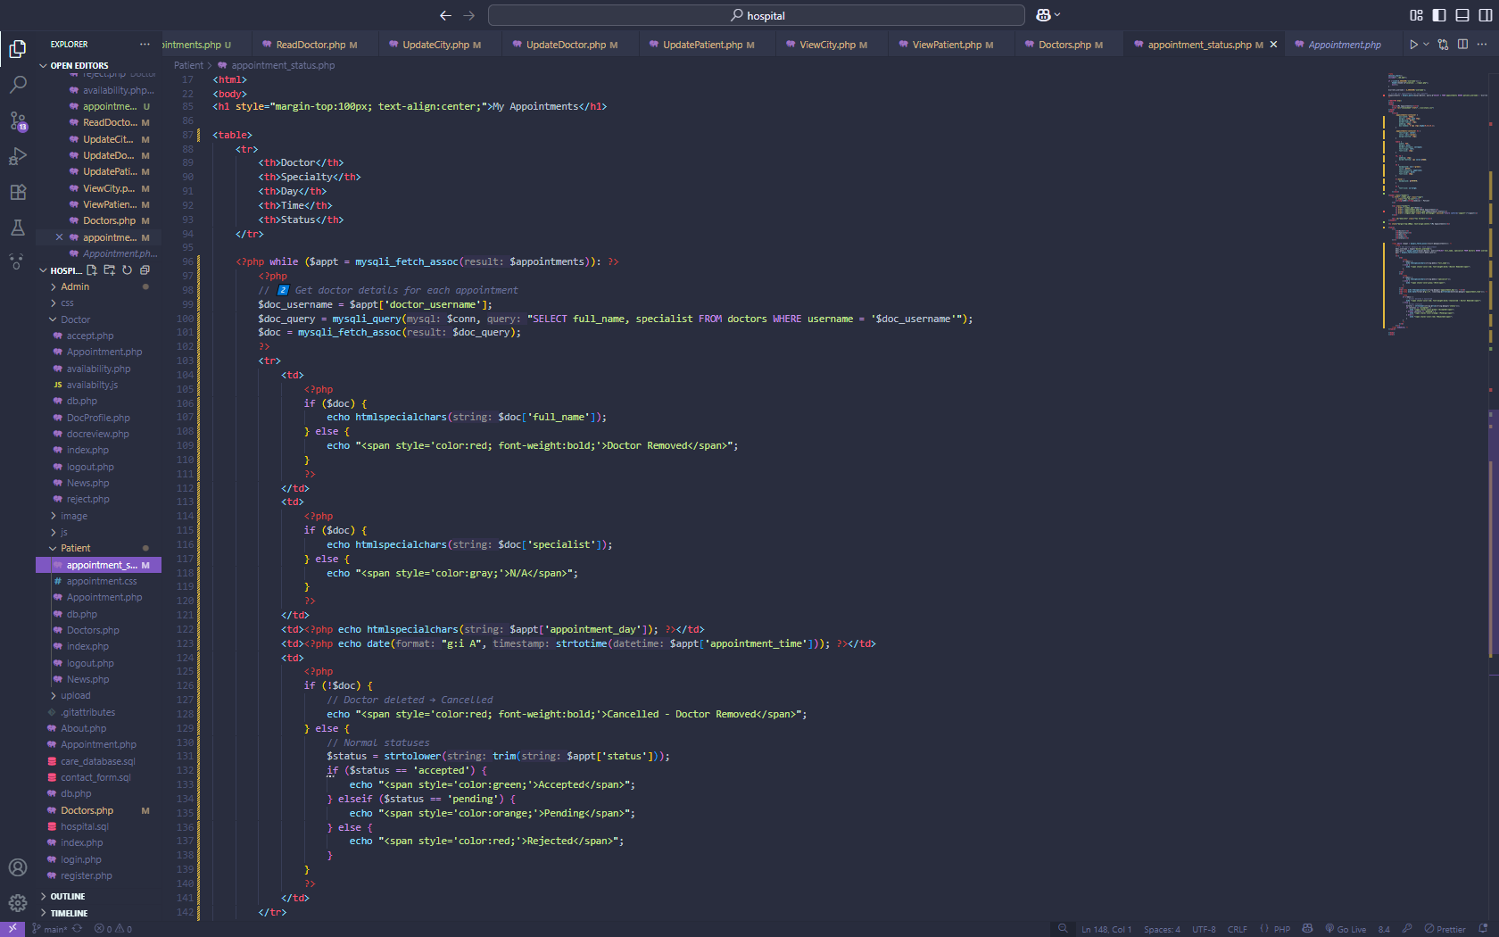

**ADMIN– Add City**

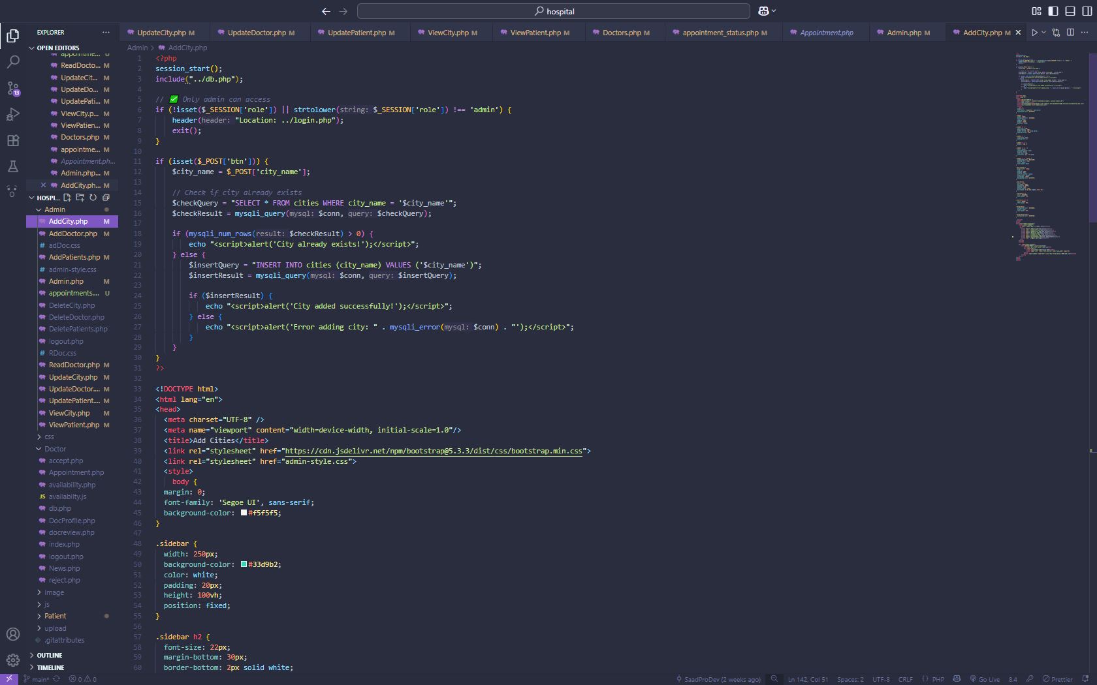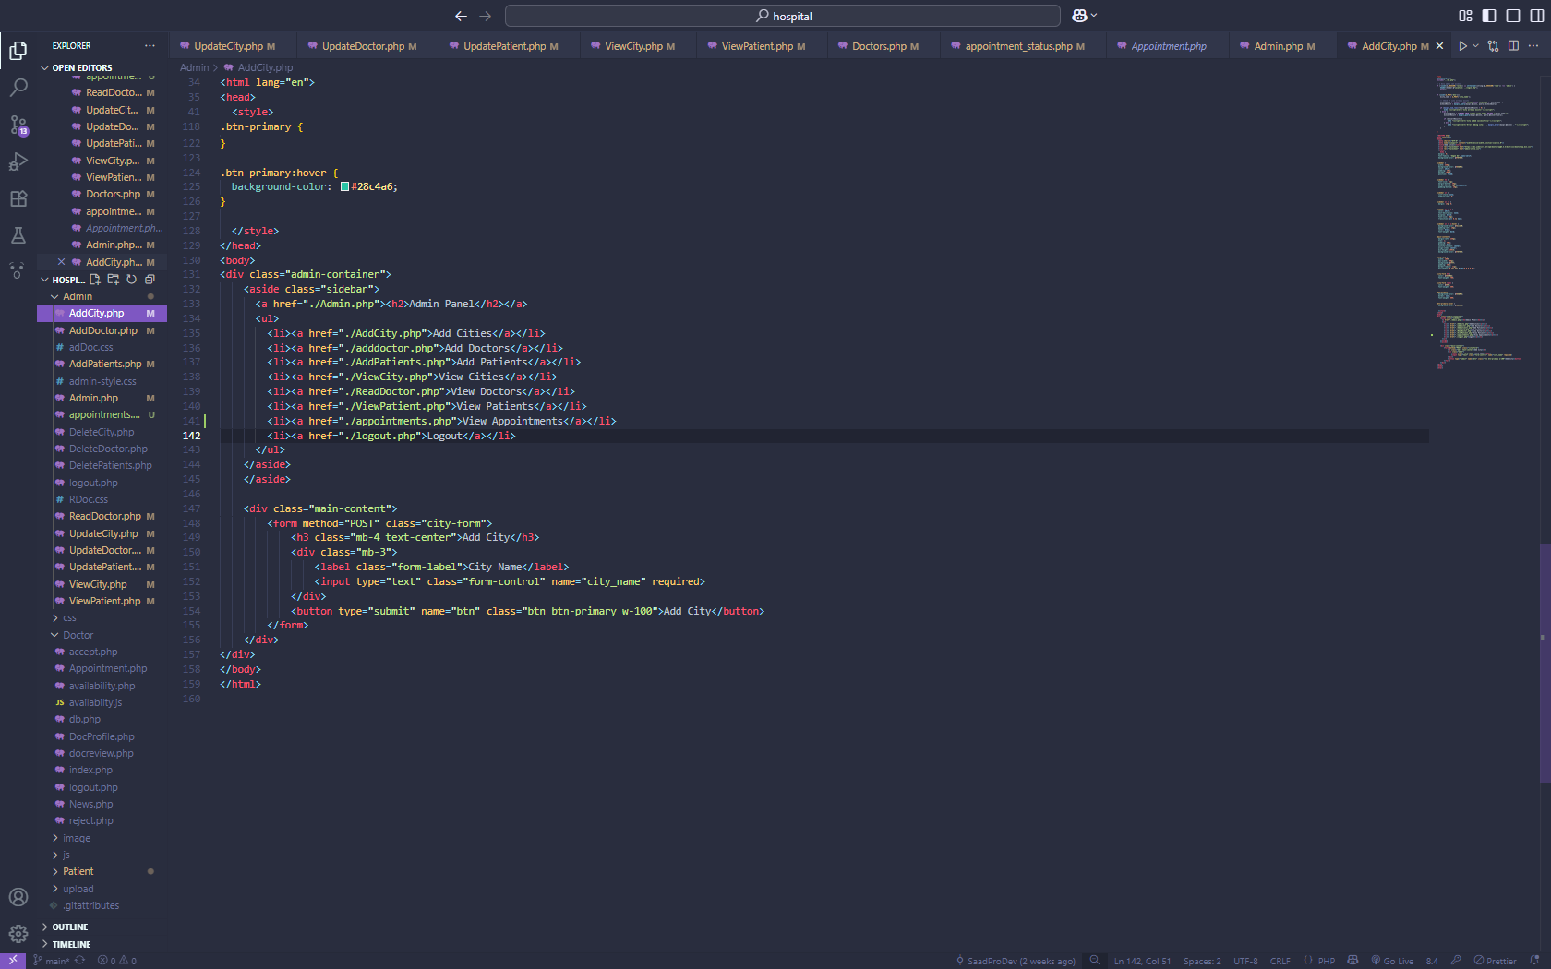

**Admin – Add Doctor**

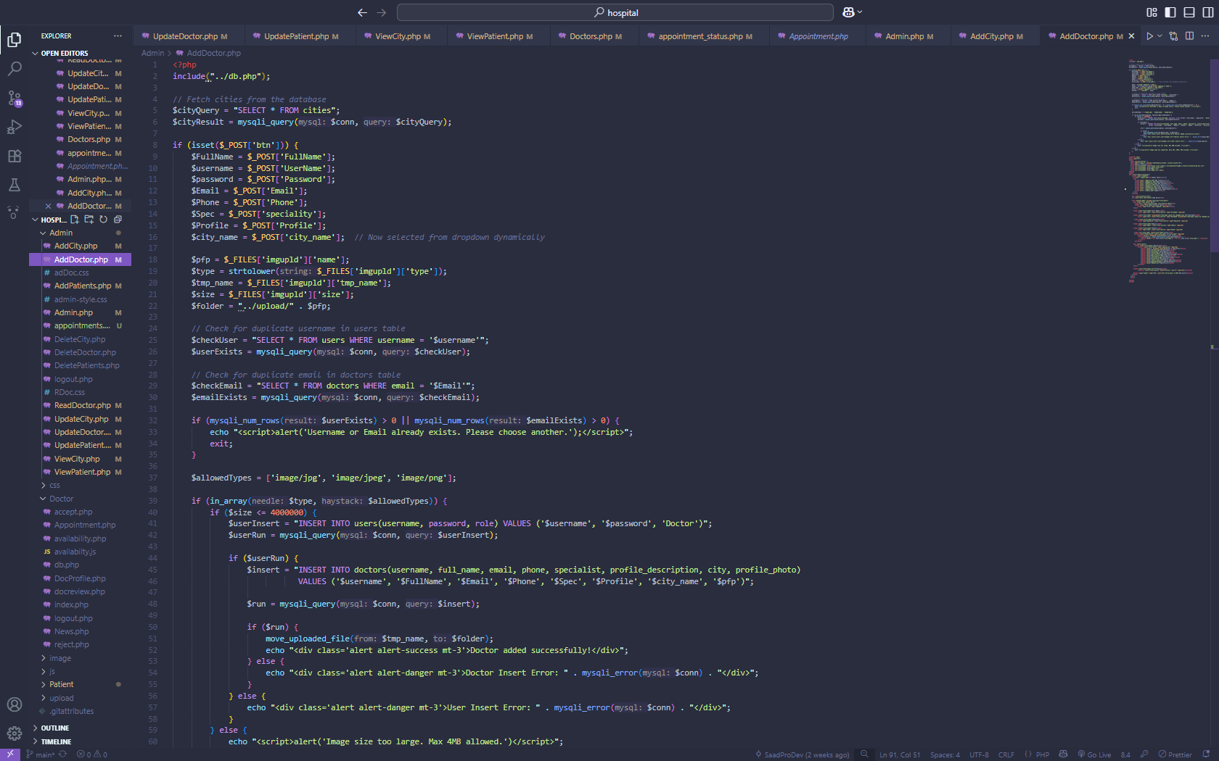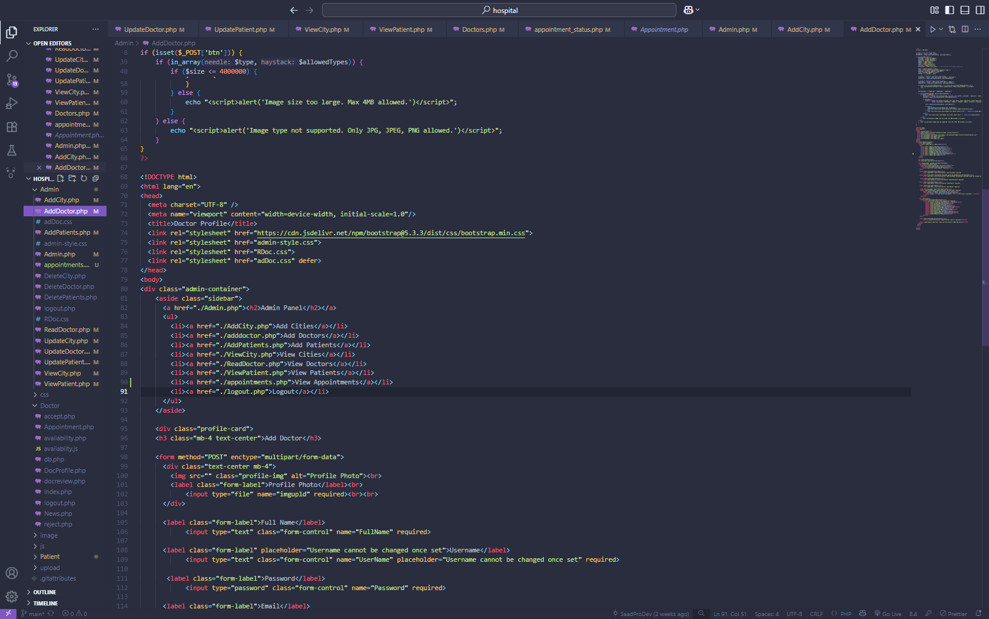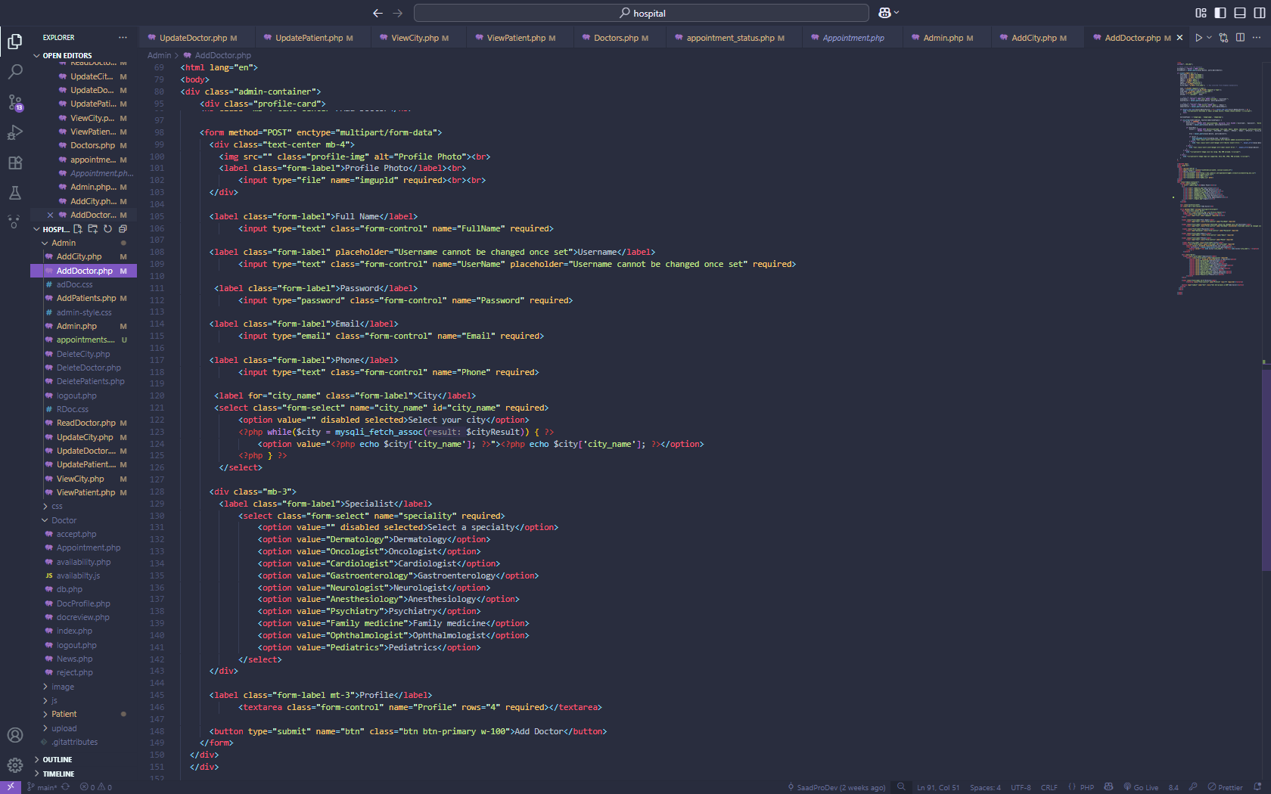

**Admin–ADD Patients PAGE**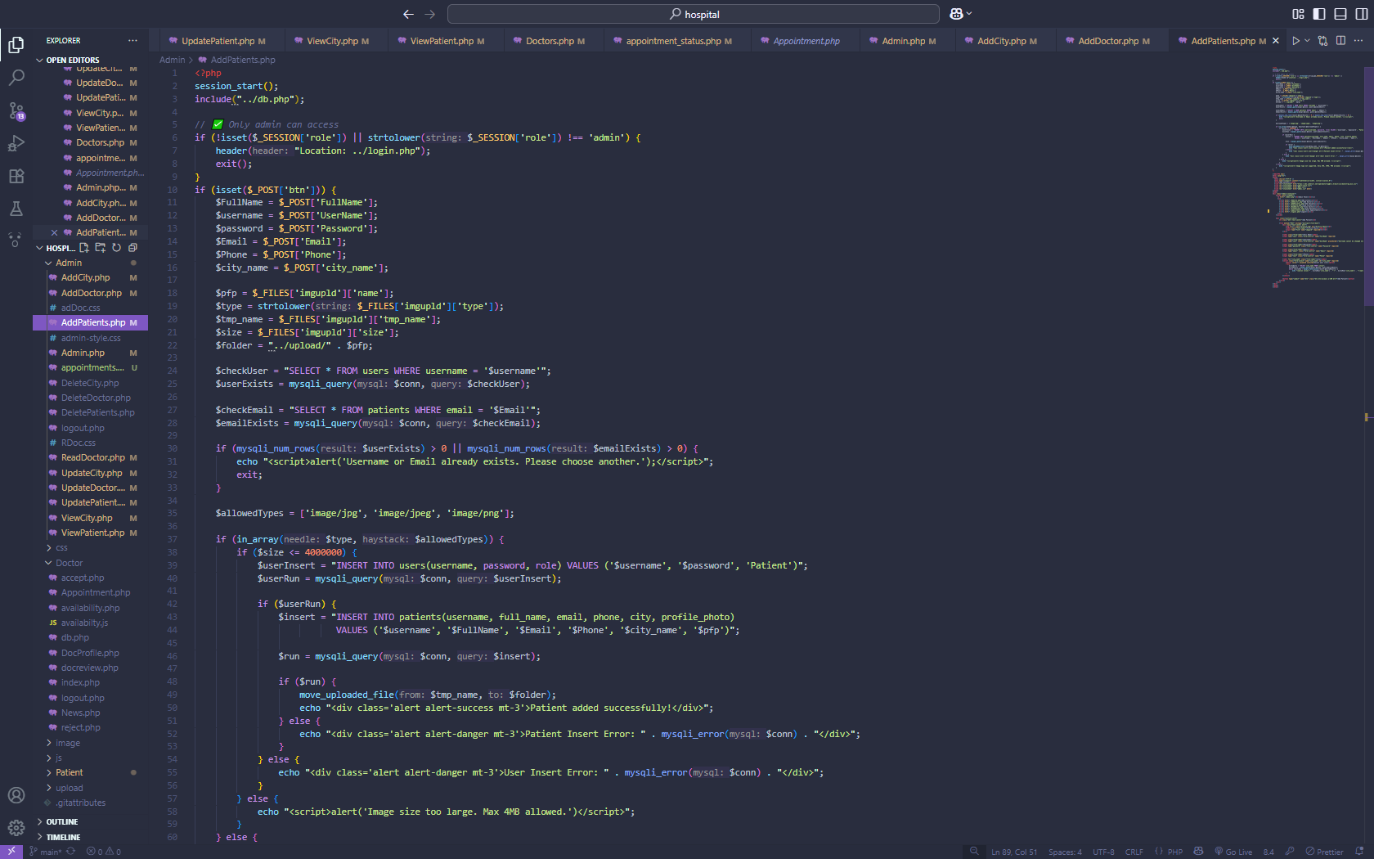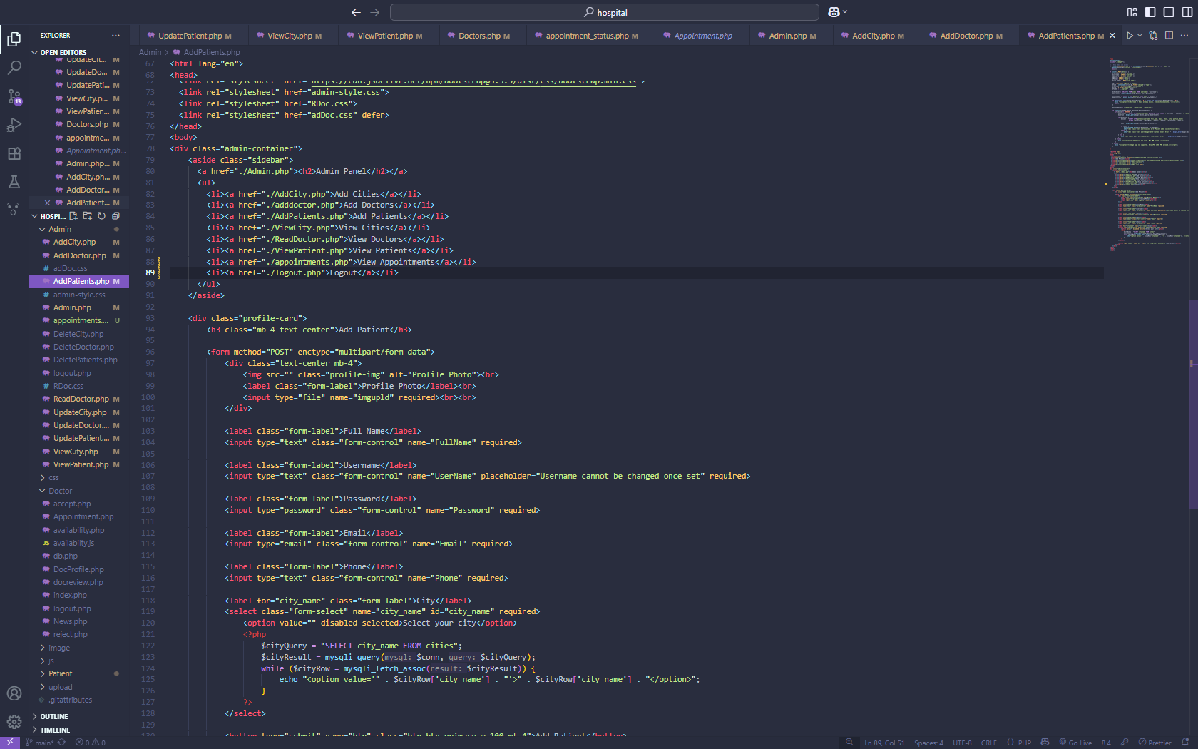

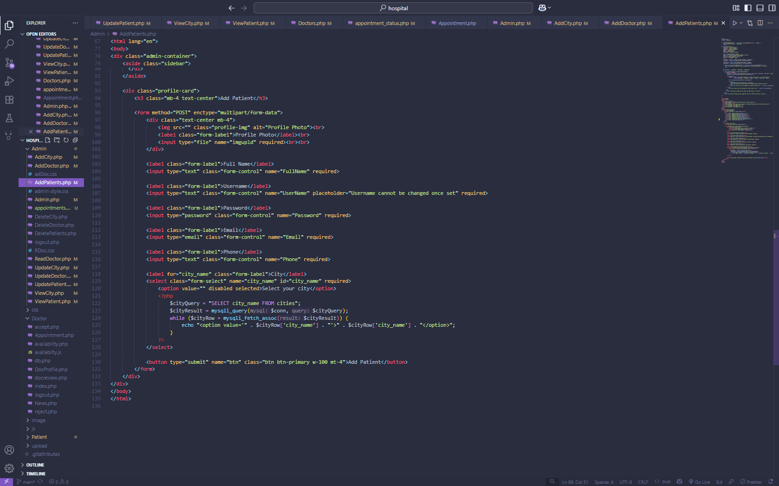

**Admin – Home Page**

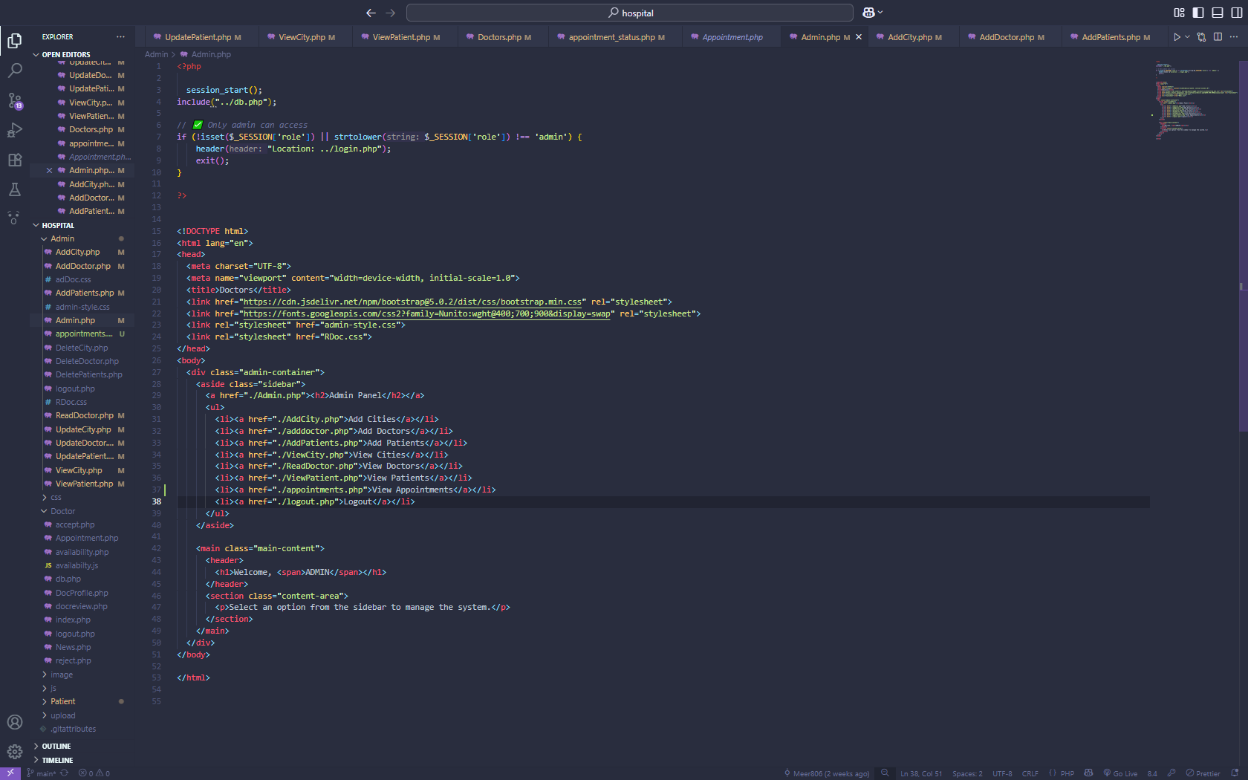

**Admin – View Appointments**

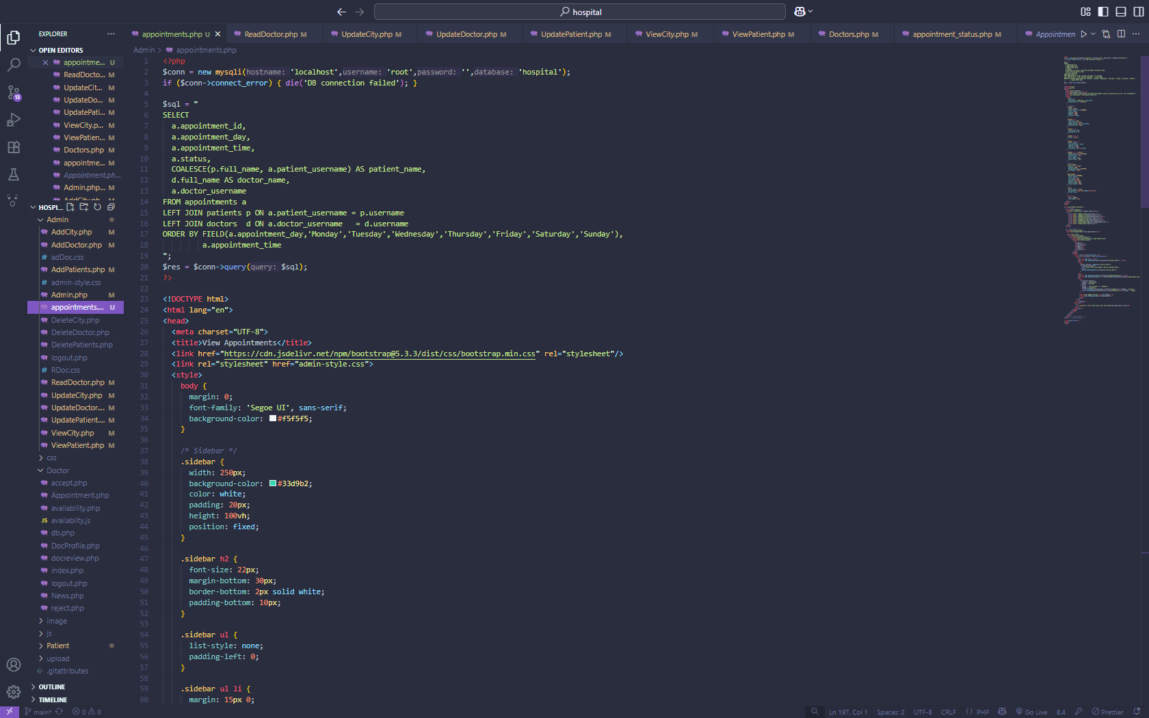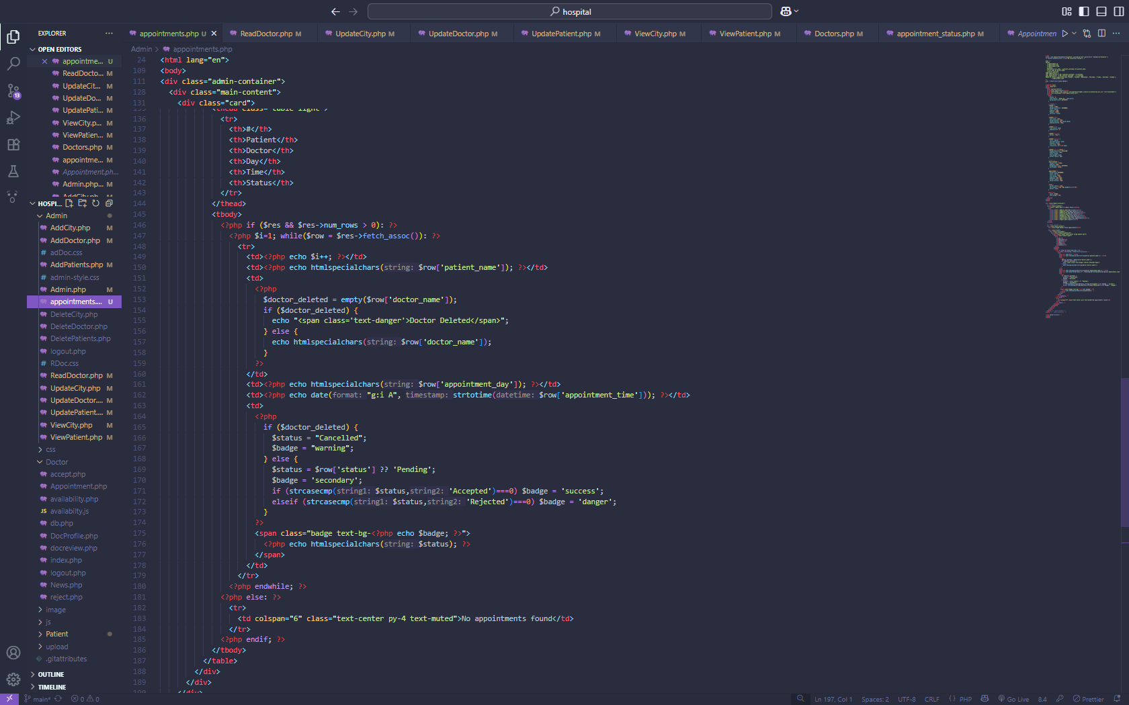

**Admin – Delete City, Doctor, Patients**

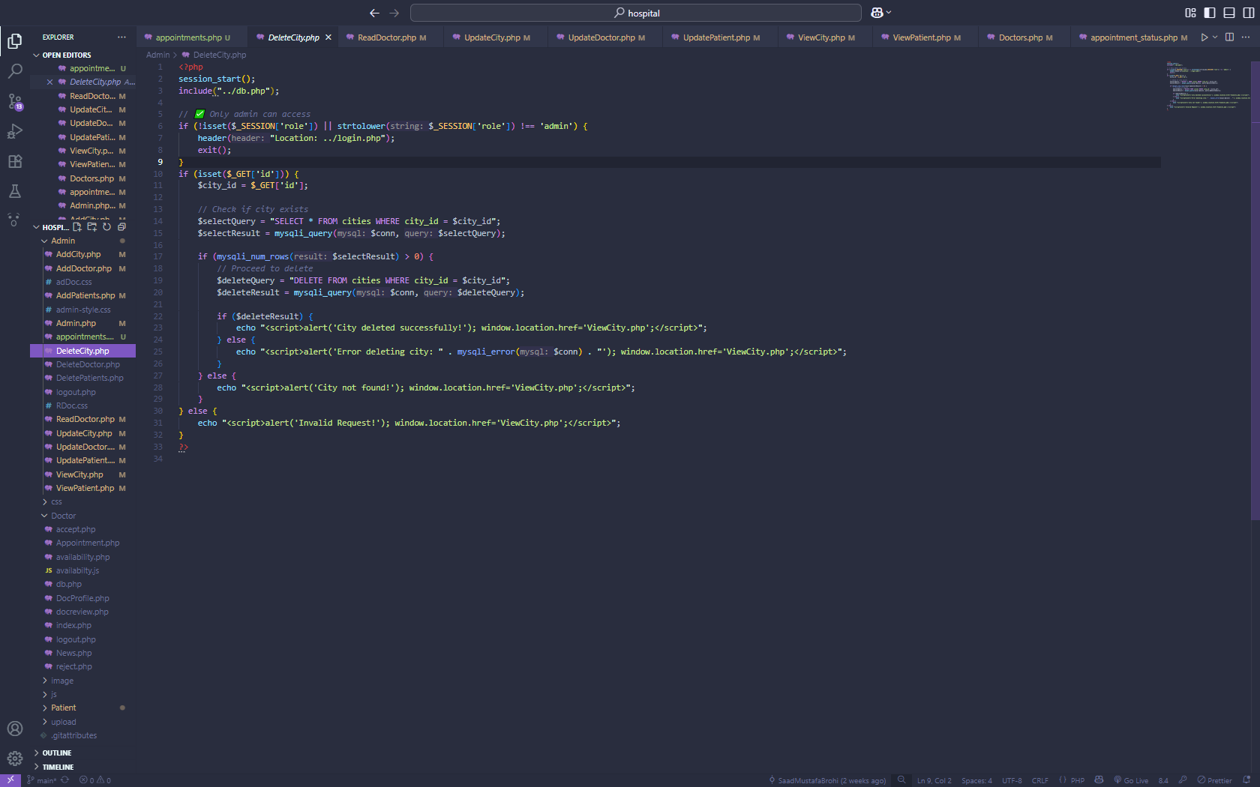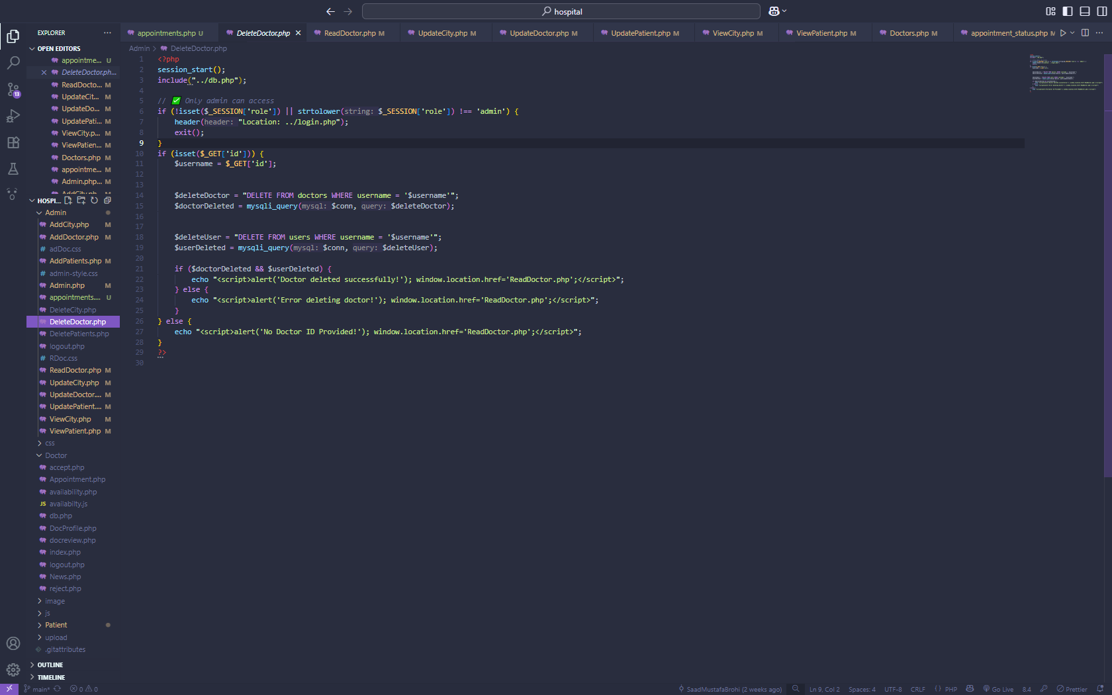



**Admin – Read Doctor**

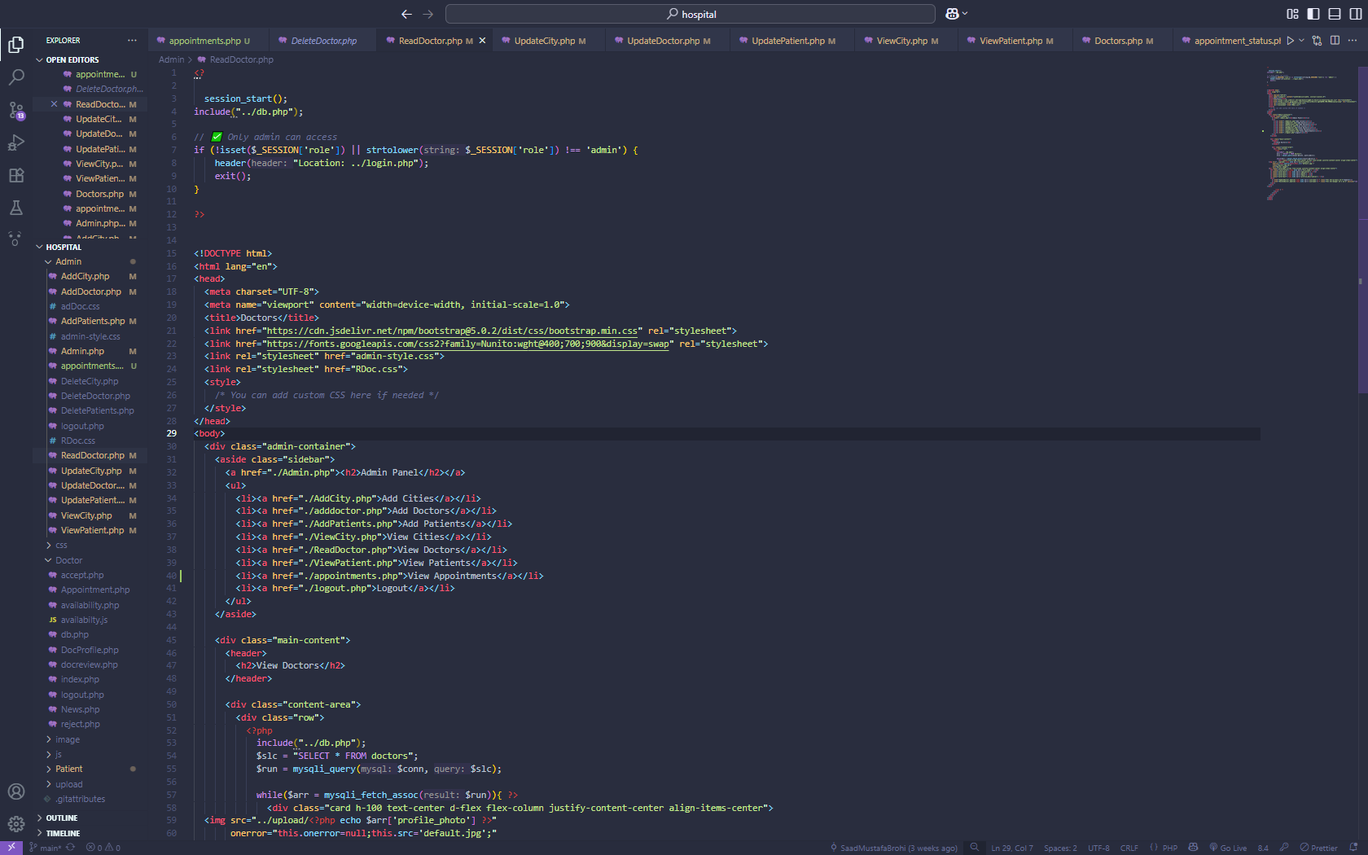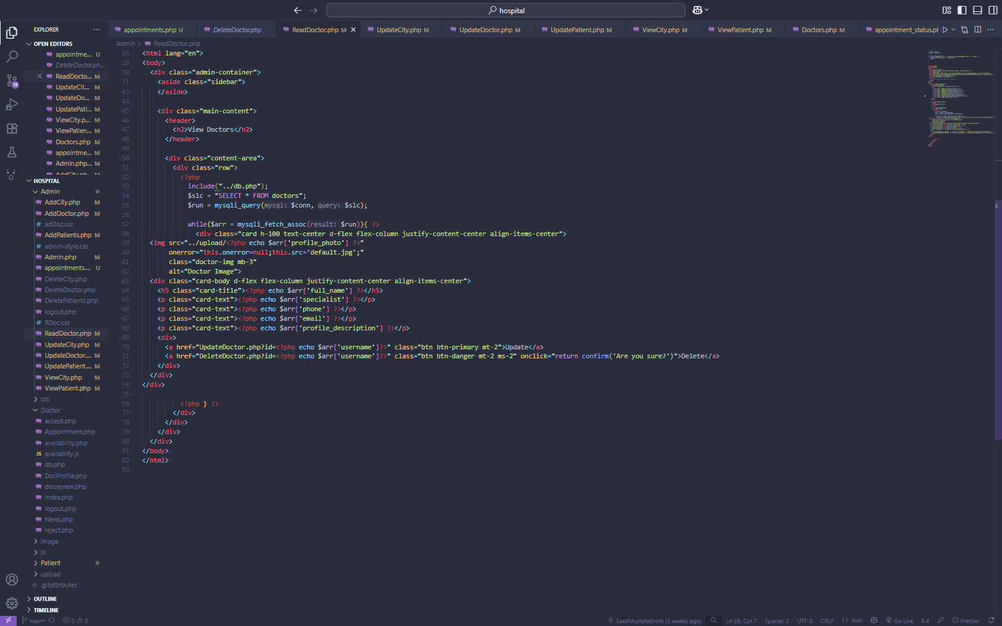

**Admin – Read City**

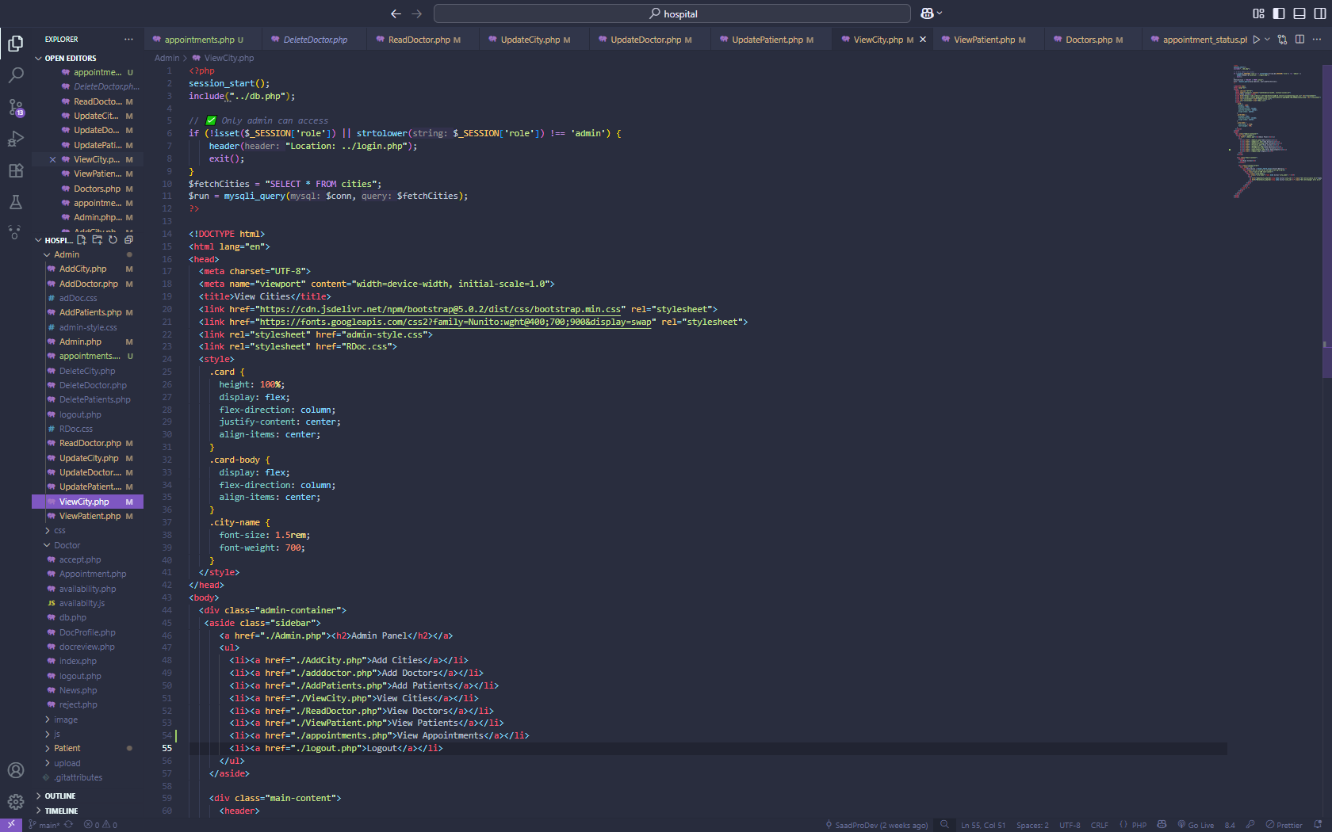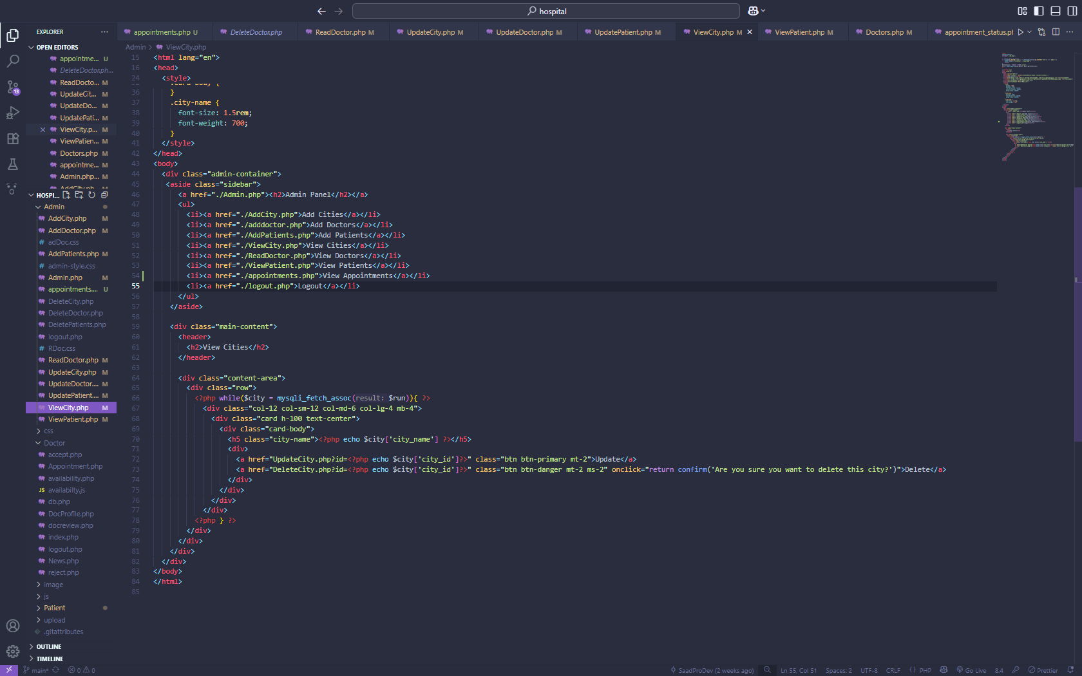

**Admin – Read Patient**

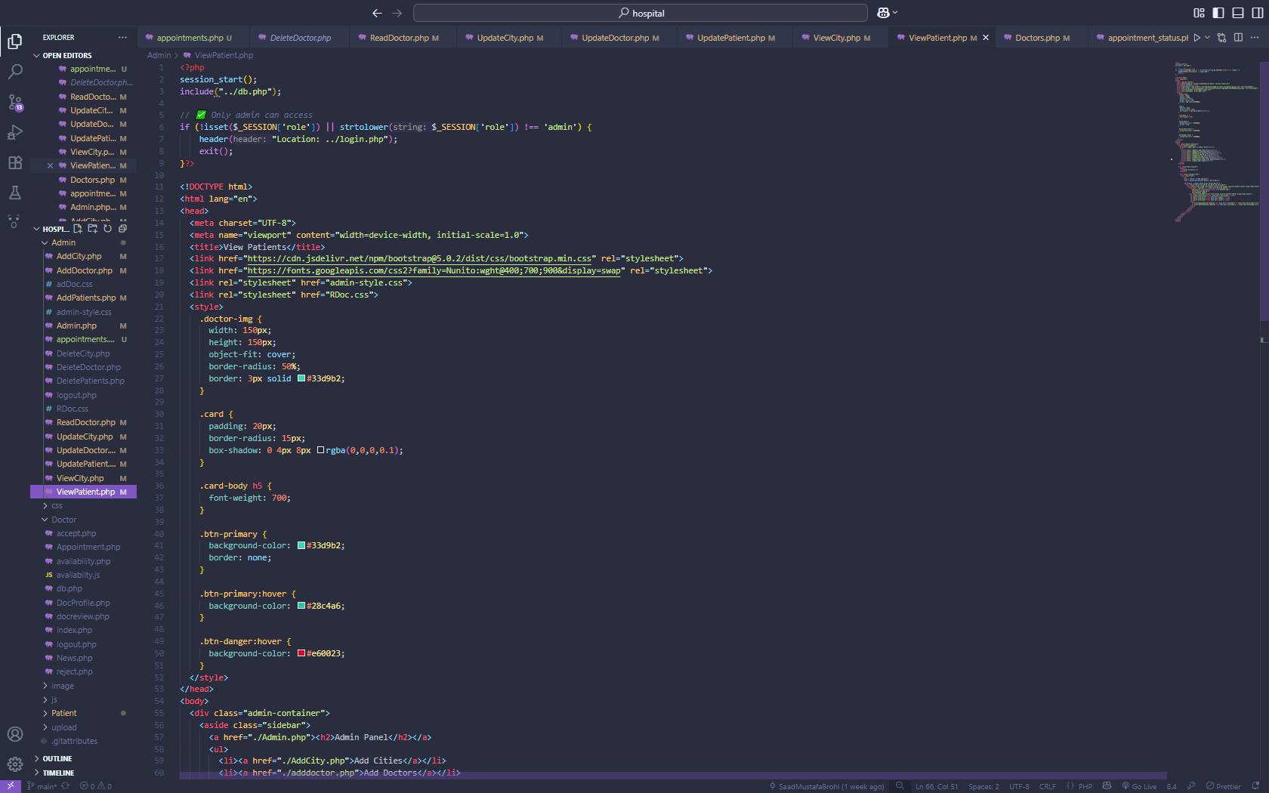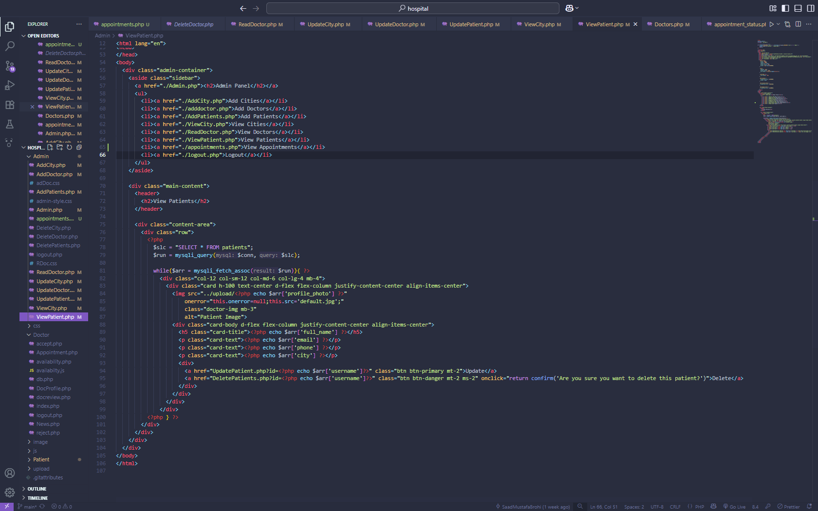

**Admin – Update City**

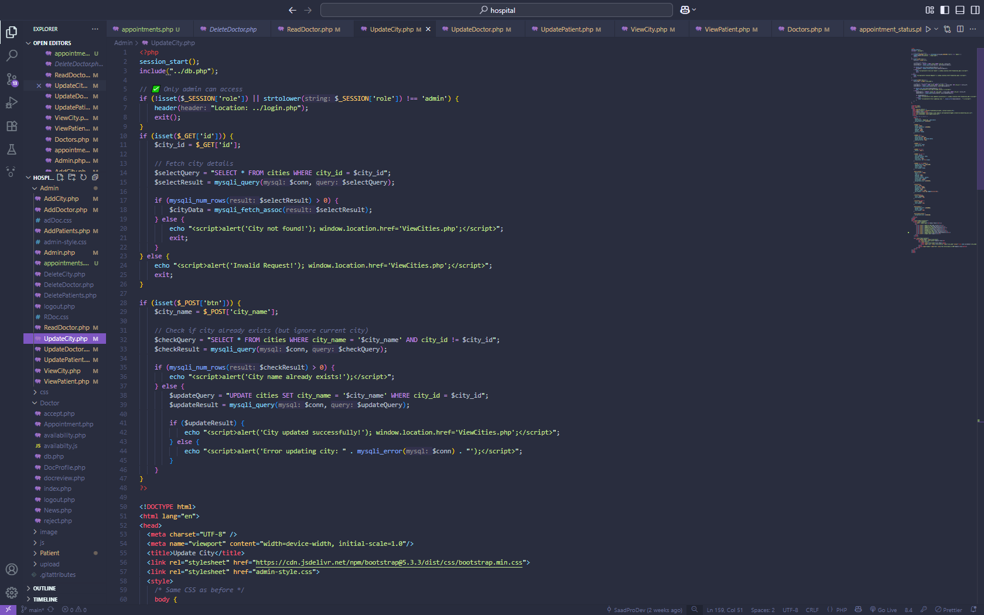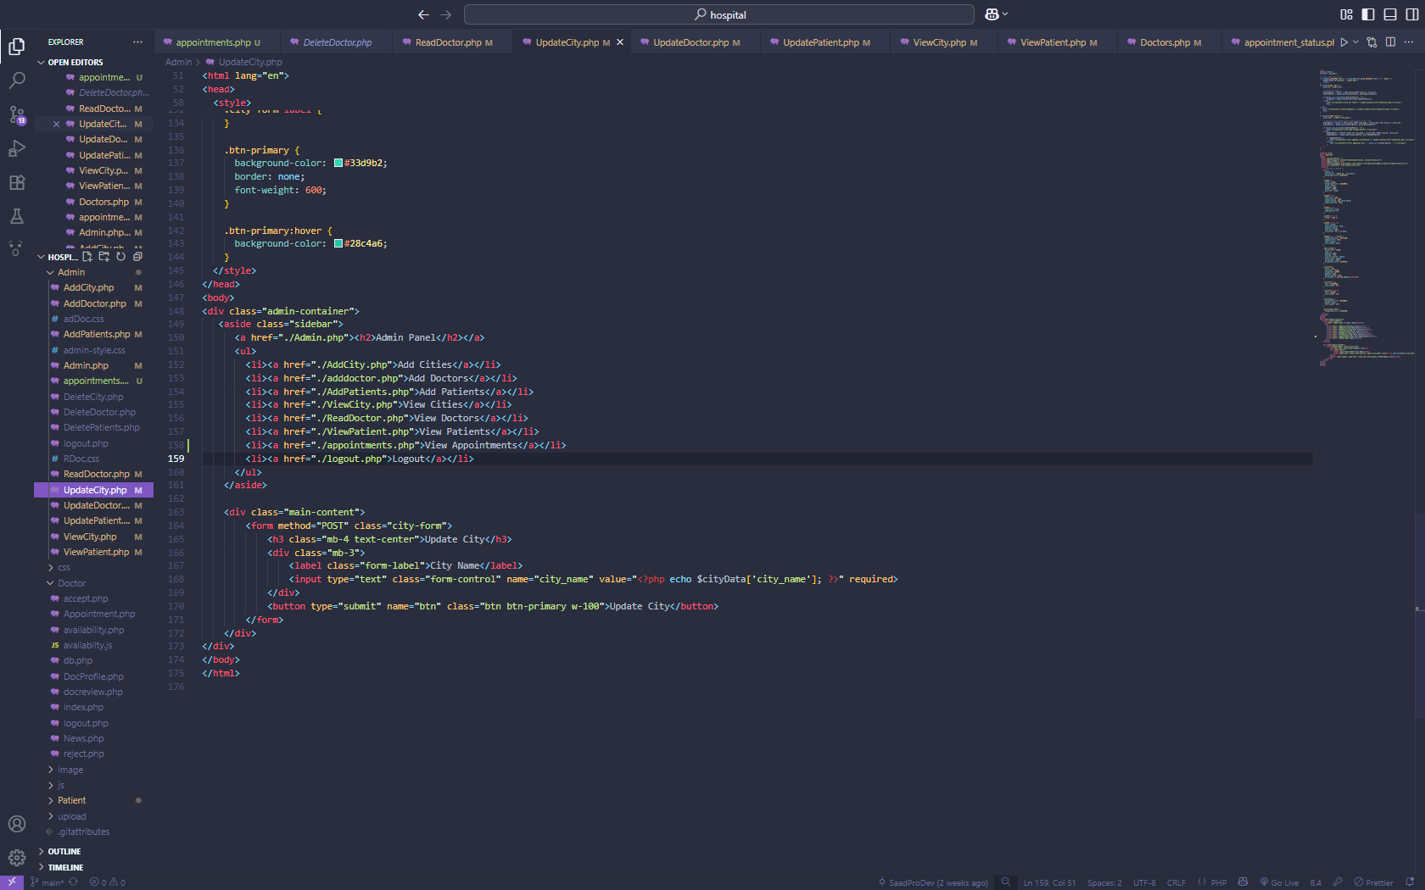

**Admin – Update Doctor**

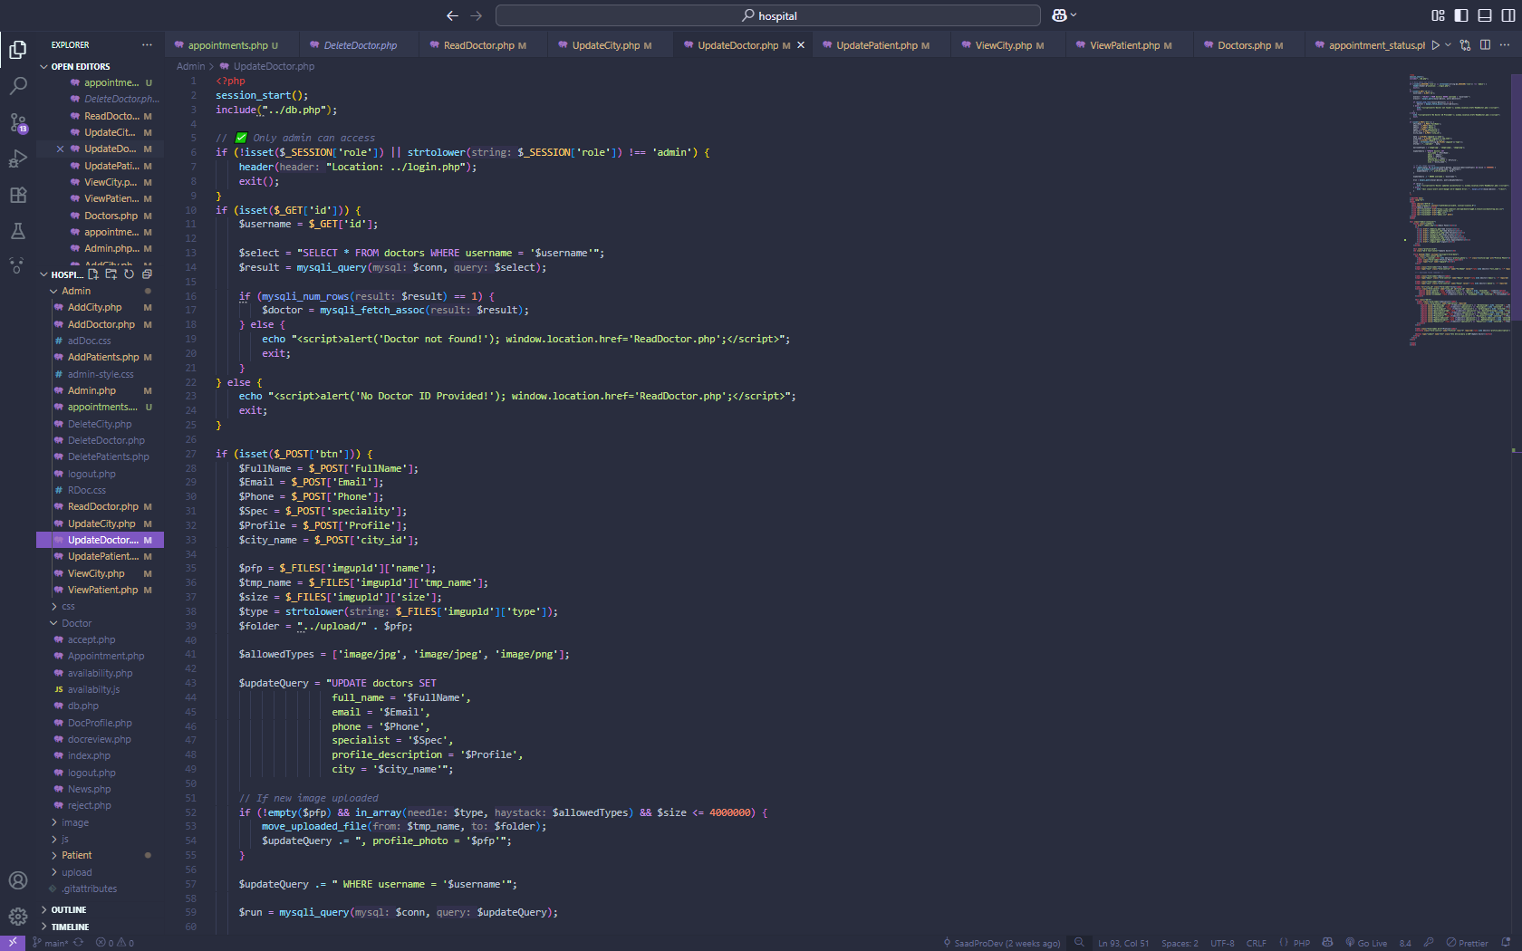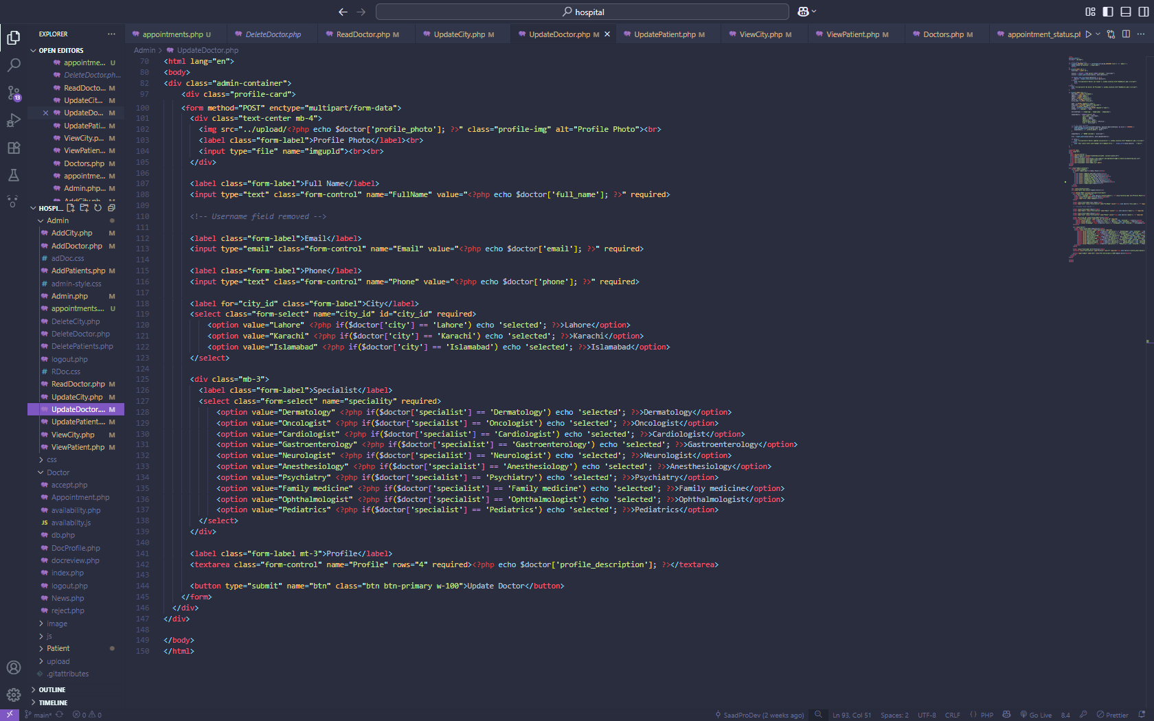

**Admin – Update Patient**

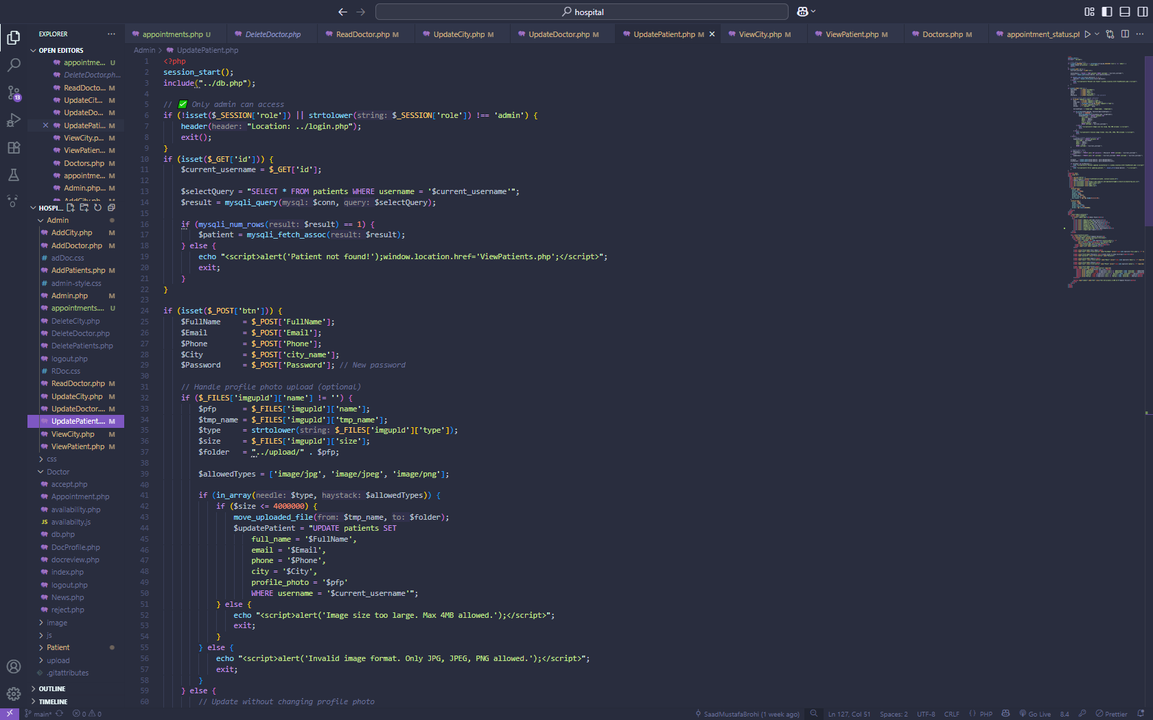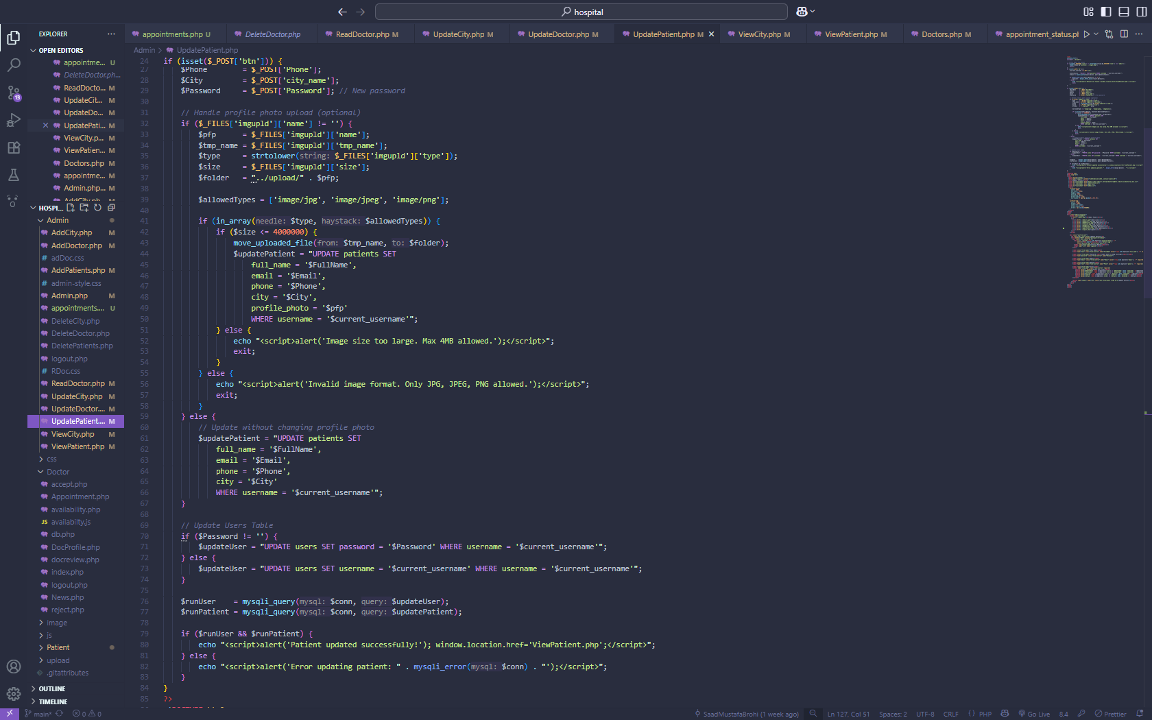

**Admin – Update Patient**

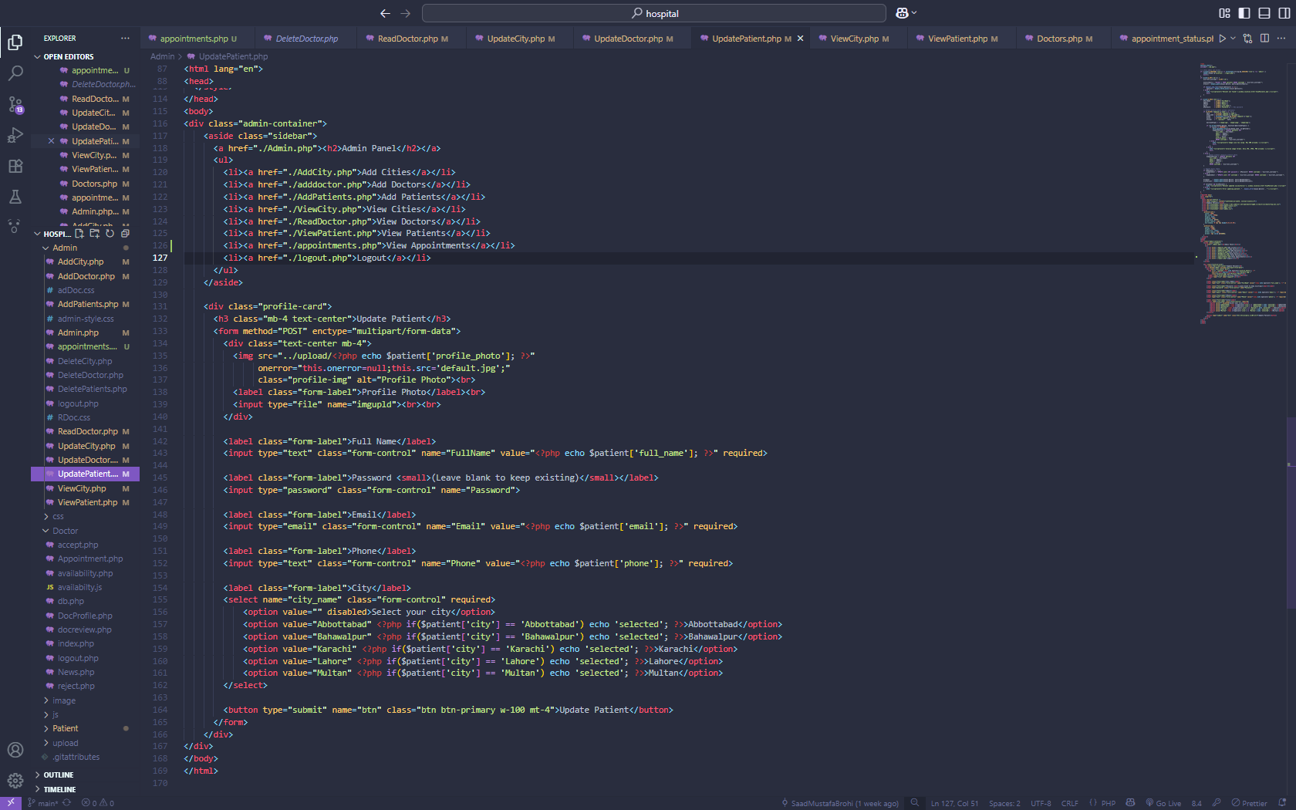

Thank you